1. Data structure 1_Arrays_Chapter 1
TASK1:
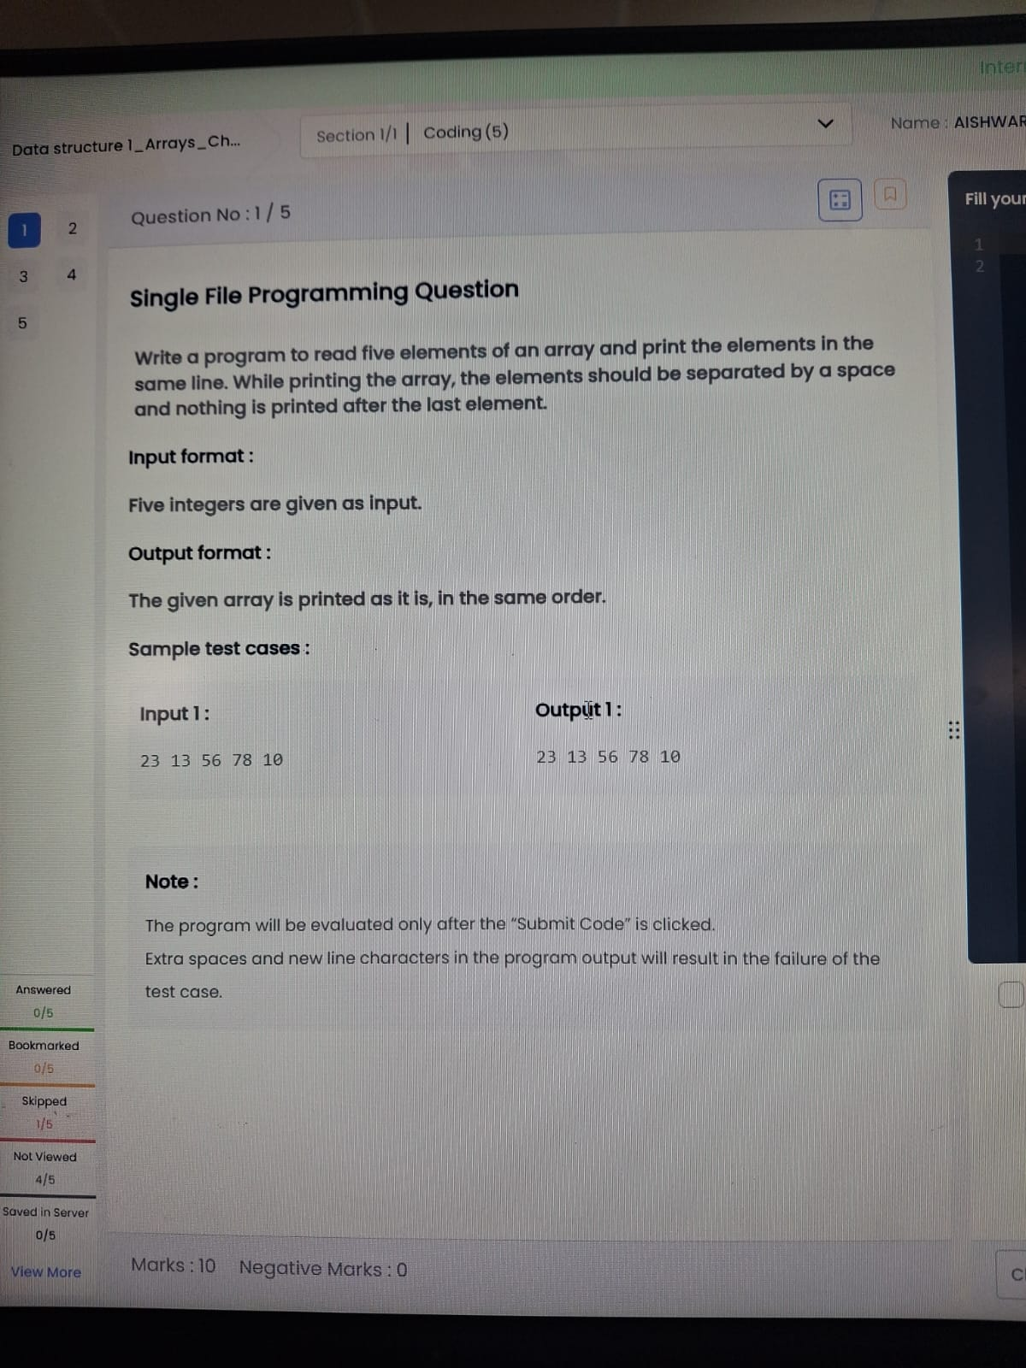

import java.util.*;
public class Main {
public static void main(String[] args) {
Scanner sc = new Scanner(System.in);
int[] a = new int[5];
for(int i=0;i<5;i++)
a[i] = sc.nextInt();
for(int i=0;i<5;i++){
System.out.print(a[i]);
if(i<4) System.out.print(" ");
}
}
}

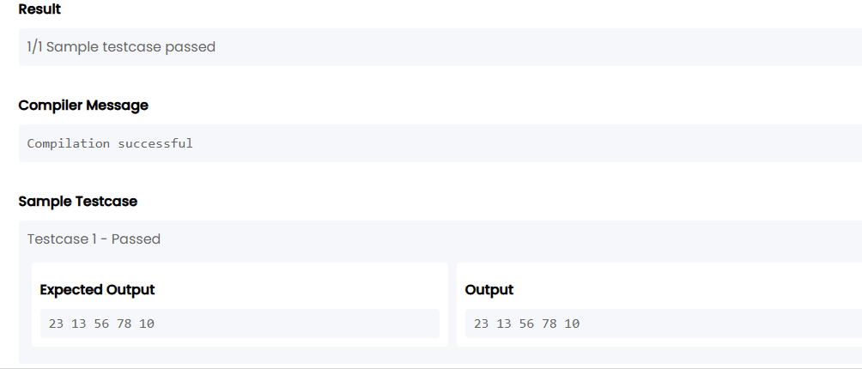
TASK2:
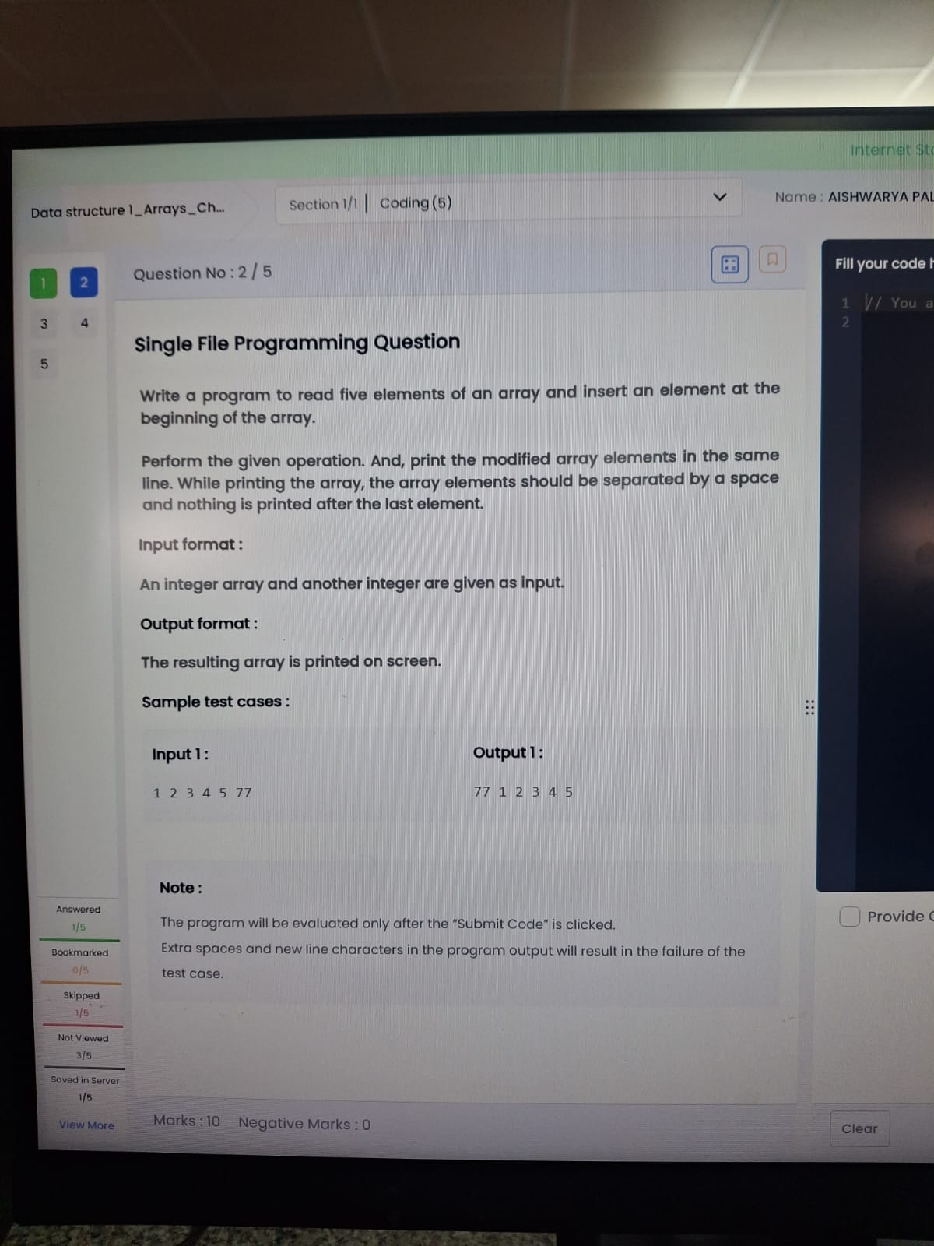
import java.util.*;
public class Main {
public static void main(String[] args) {
Scanner sc = new Scanner(System.in);
int[] a = new int[5];
for(int i=0;i<5;i++)
a[i] = sc.nextInt();
int x = sc.nextInt();
System.out.print(x + " ");
for(int i=0;i<5;i++){
System.out.print(a[i]);
if(i<4) System.out.print(" ");
}
}
}
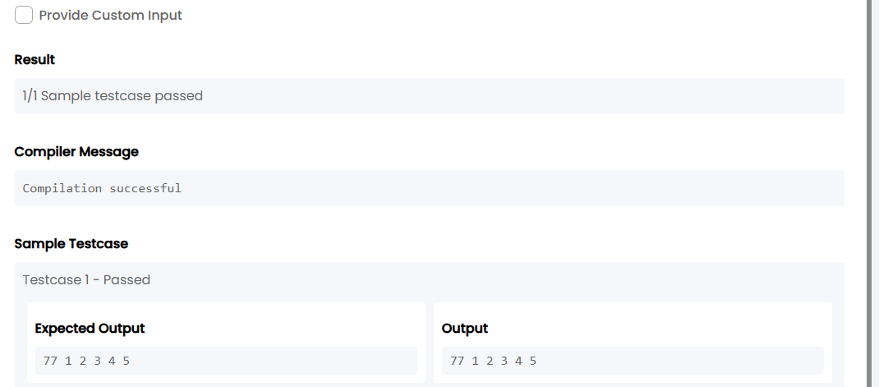
TASK3:
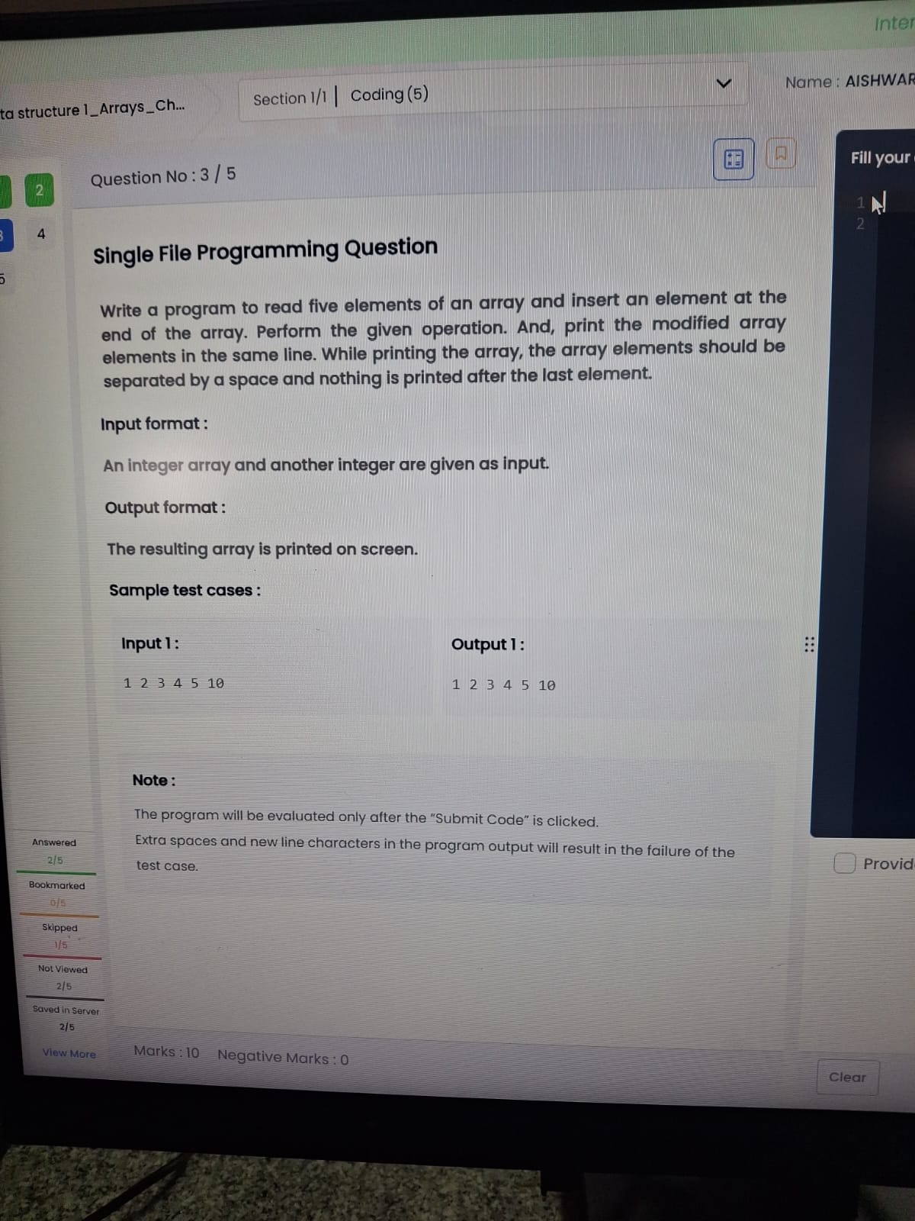

import java.util.*;
public class Main {
public static void main(String[] args) {
Scanner sc = new Scanner(System.in);
int[] a = new int[6];
for(int i=0;i<5;i++)
a[i] = sc.nextInt();
a[5] = sc.nextInt();
for(int i=0;i<6;i++){
System.out.print(a[i]);
if(i<5) System.out.print(" ");
}
}
}
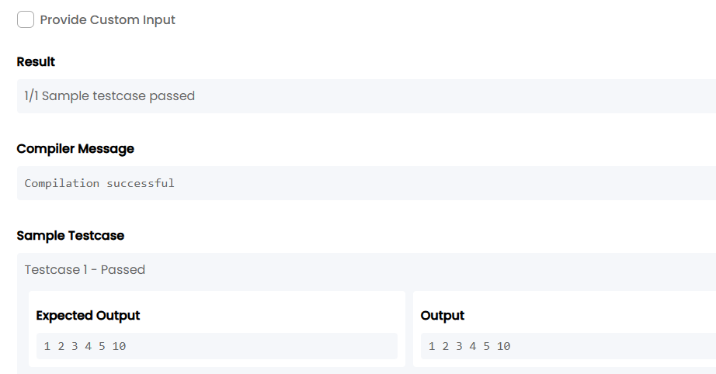

TASK4:
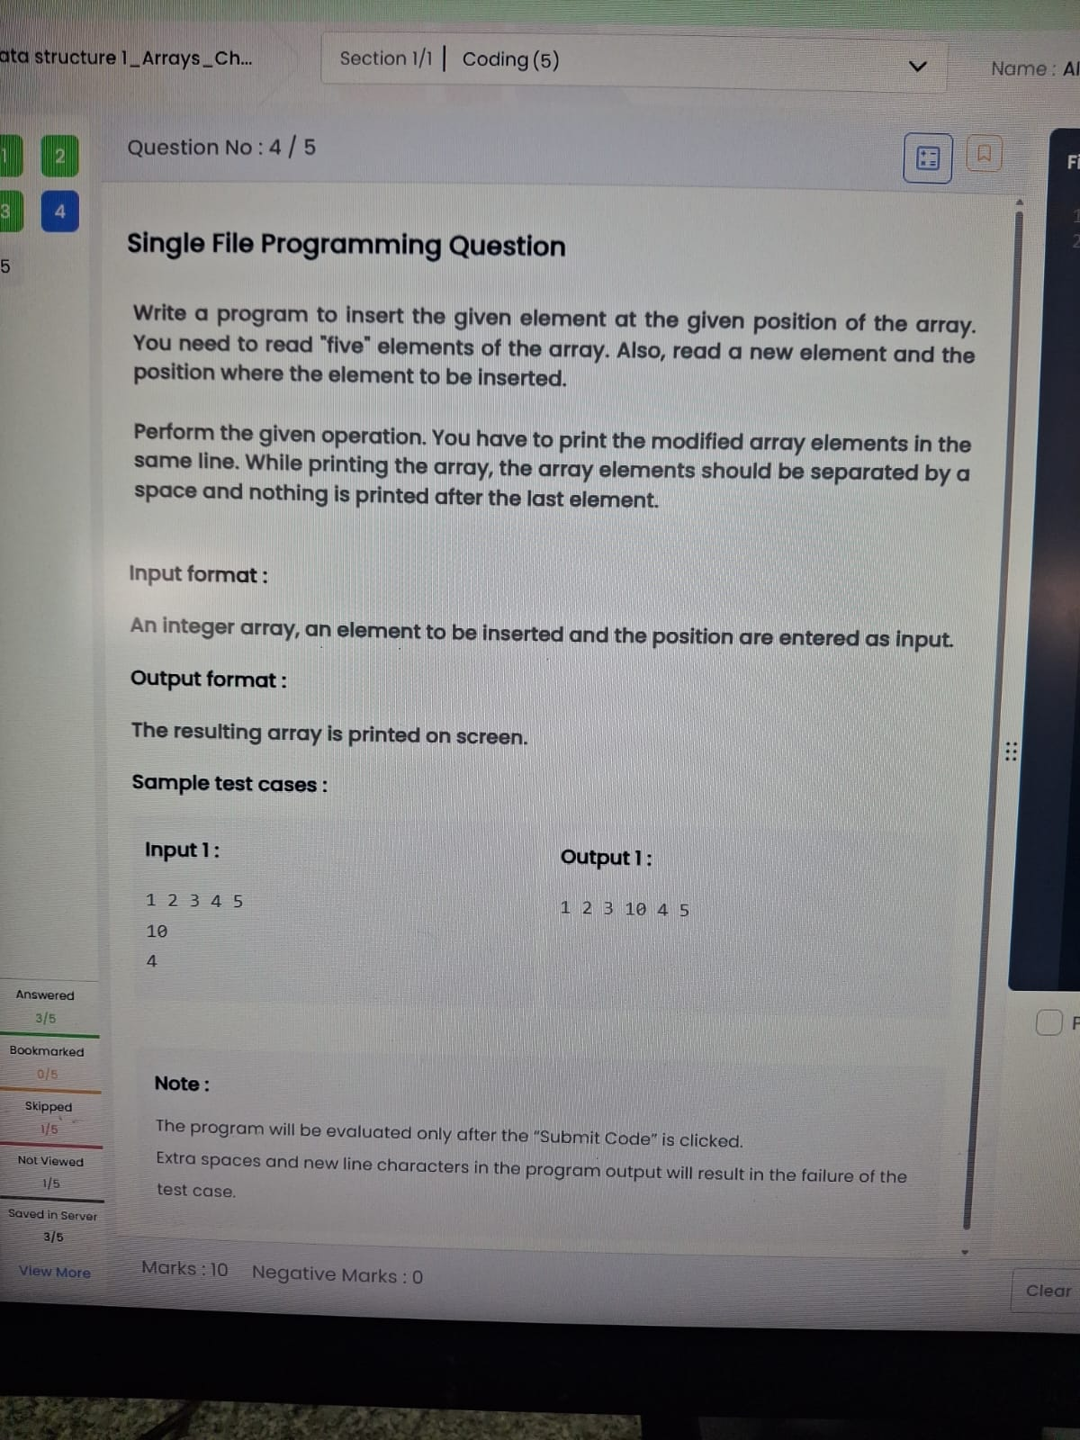
import java.util.*;
public class Main {
public static void main(String[] args) {
Scanner sc = new Scanner(System.in);
int[] a = new int[5];
for(int i = 0; i < 5; i++)
a[i] = sc.nextInt();
int x = sc.nextInt();
int pos = sc.nextInt();
int[] b = new int[6];
for(int i = 0, j = 0; i < 6; i++) {
if(i == pos - 1)
b[i] = x;
else
b[i] = a[j++];
}
for(int i = 0; i < 6; i++) {
System.out.print(b[i]);
if(i < 5) System.out.print(" ")} }
}
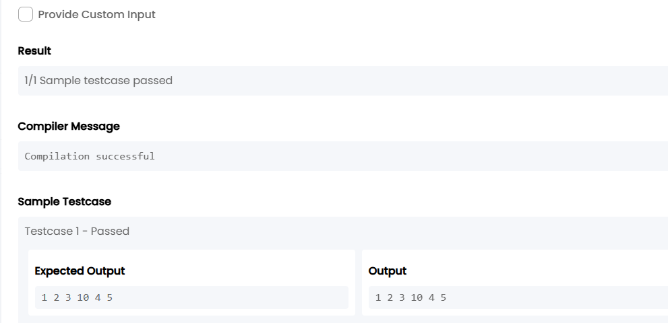
TASK5:
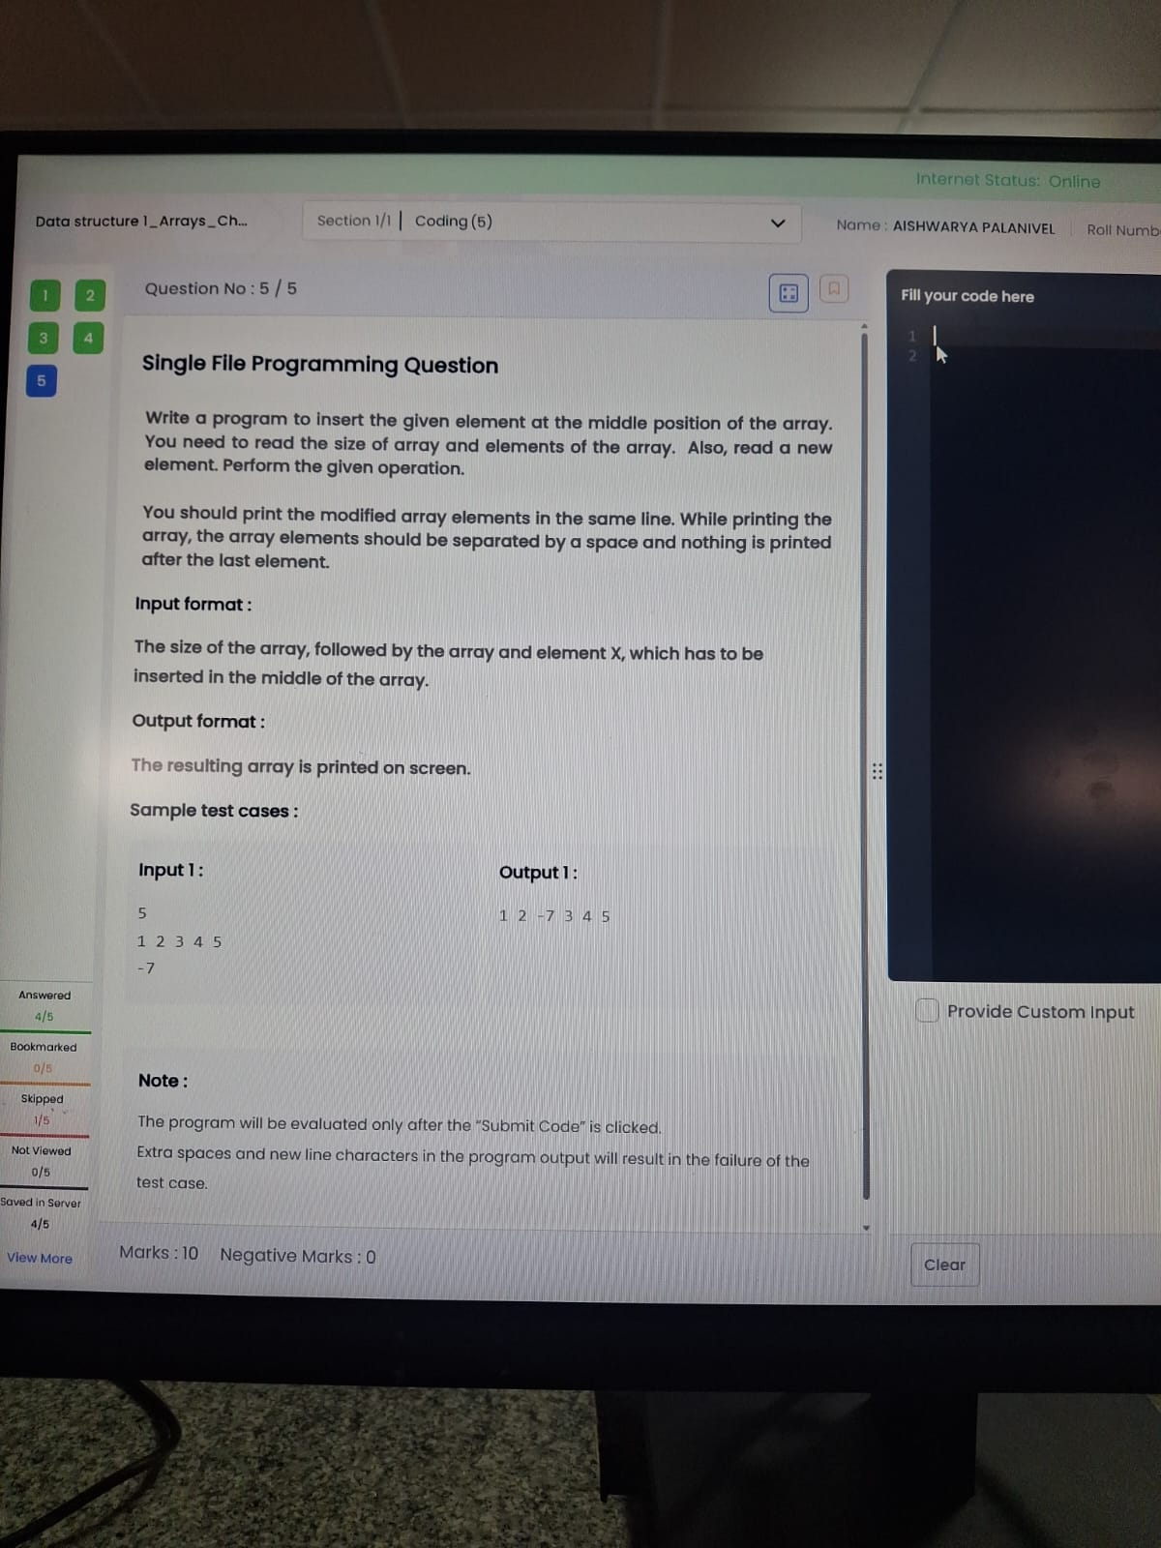
import java.util.*;
public class Main {
public static void main(String[] args) {
Scanner sc = new Scanner(System.in);
int n = sc.nextInt();
int[] a = new int[n];
for(int i = 0; i < n; i++)
a[i] = sc.nextInt();
int x = sc.nextInt();
int[] b = new int[n + 1];
int mid = n / 2;
for(int i = 0, j = 0; i < n + 1; i++) {
if(i == mid)
b[i] = x;
else
b[i] = a[j++];
}
for(int i = 0; i < n + 1; i++) {
System.out.print(b[i]);
if(i < n) System.out.print(" ");}}}
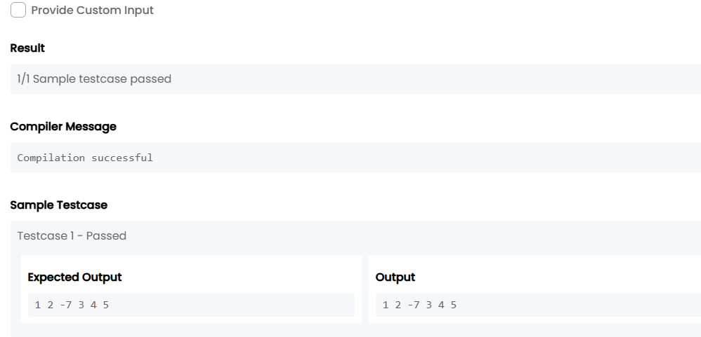

2. Data structure 1_Arrays_Chapter 2
TASK6:
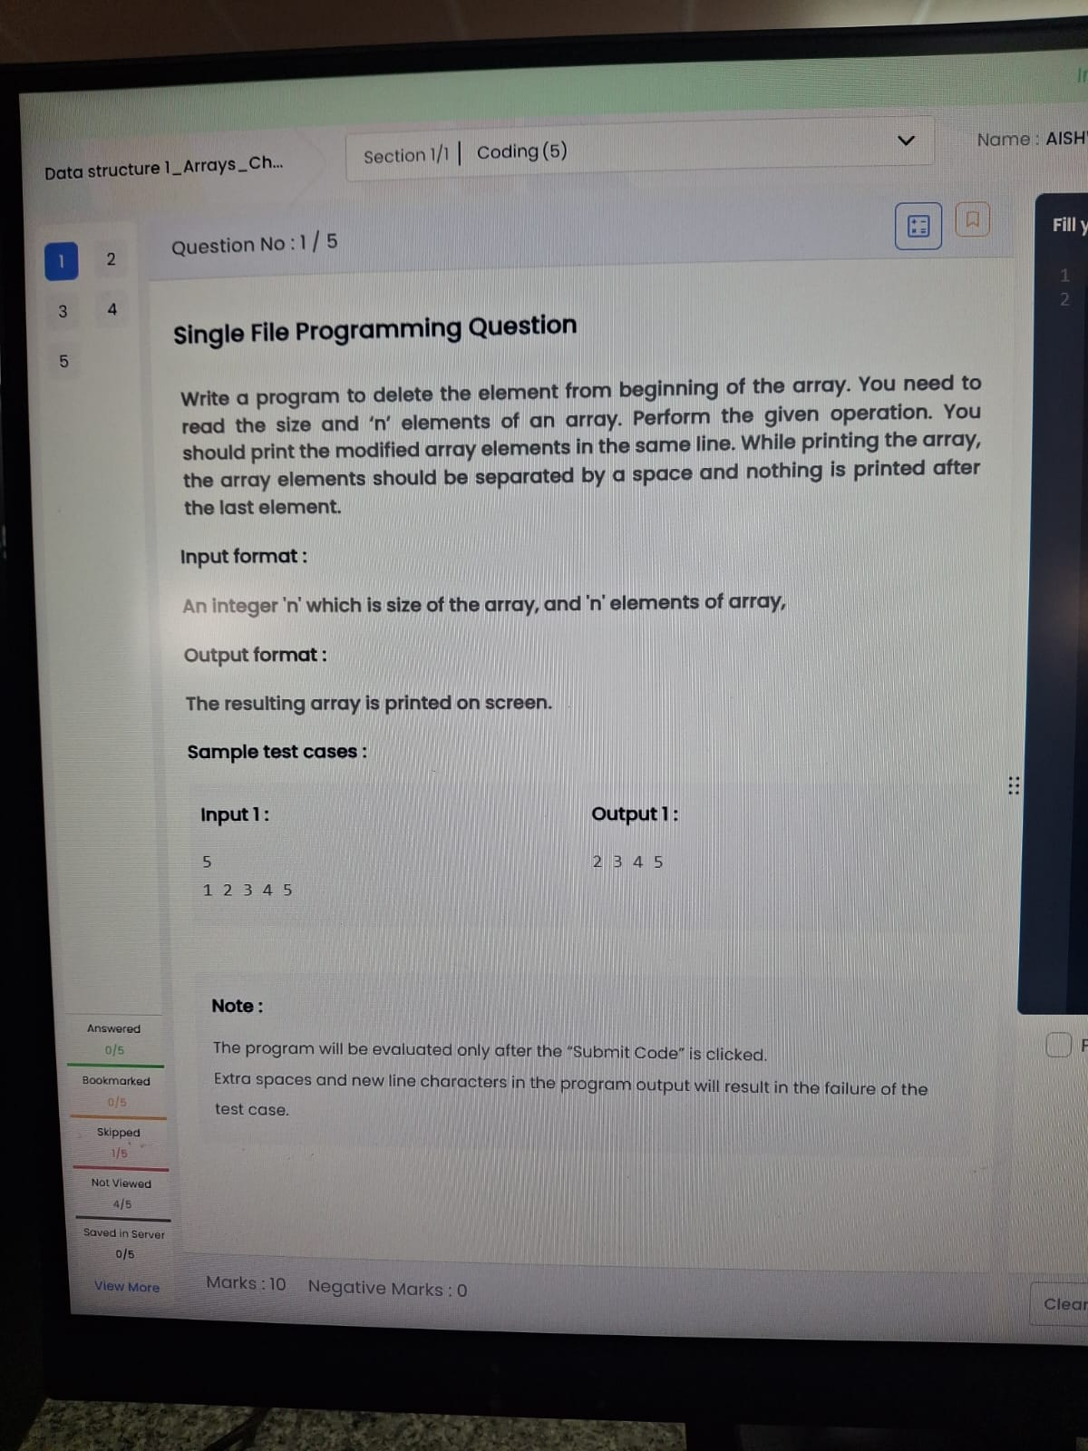
import java.util.*;
public class Main {
public static void main(String[] args) {
Scanner sc = new Scanner(System.in);
int n = sc.nextInt();
int[] a = new int[n];
for(int i = 0; i < n; i++)
a[i] = sc.nextInt();
for(int i = 1; i < n; i++) {
System.out.print(a[i]);
if(i < n-1) System.out.print(" ");
}
}
}

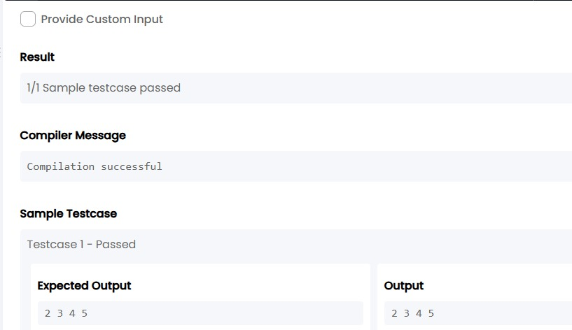
TASK7:
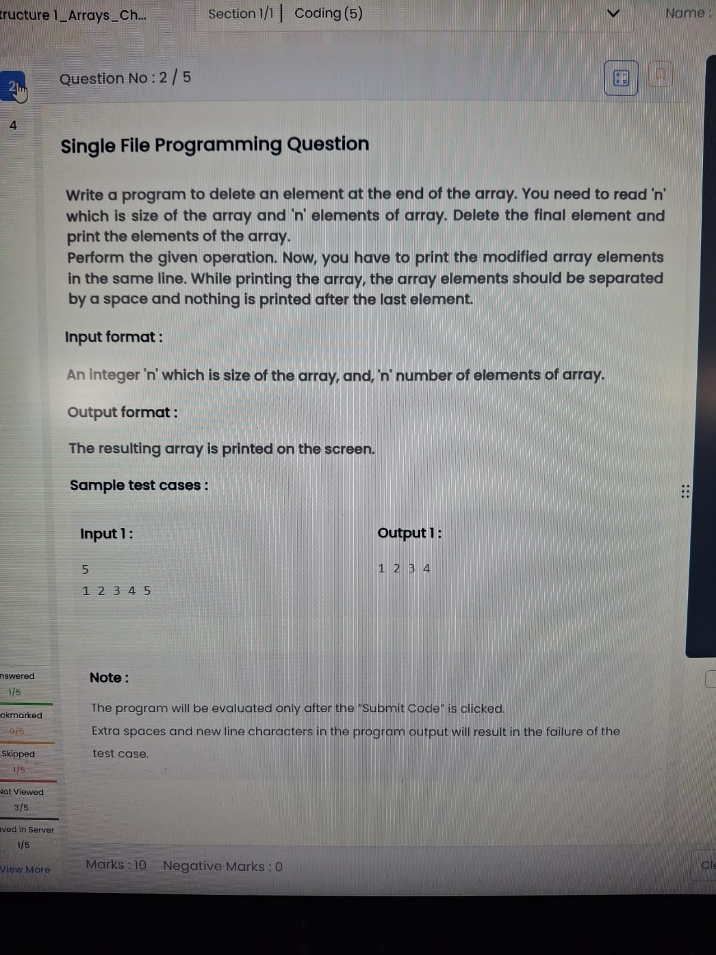

import java.util.Scanner;
public class Main {
public static void main(String[] args) {
Scanner sc = new Scanner(System.in);
int n = sc.nextInt();
int[] a = new int[n];
for(int i = 0; i < n; i++)
a[i] = sc.nextInt();
for(int i = 0; i < n - 1; i++) {
System.out.print(a[i]);
if(i < n - 2)
System.out.print(" ");
}
}
}
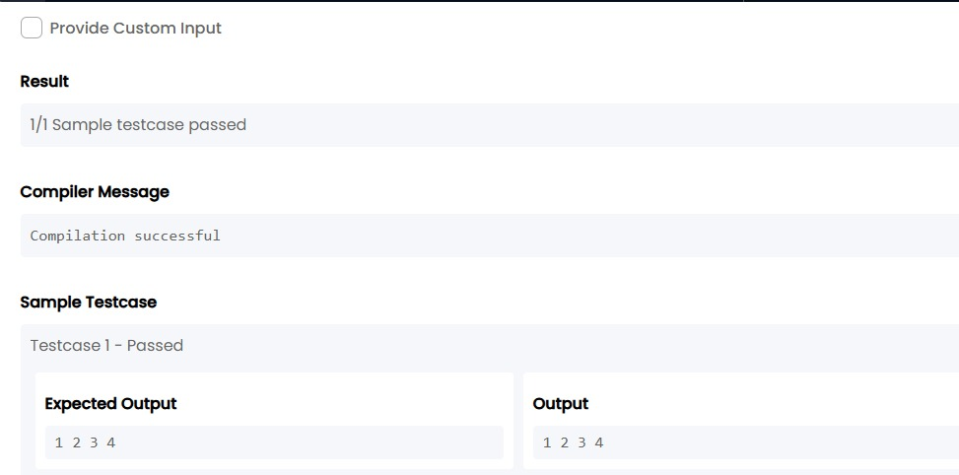

TASK8:
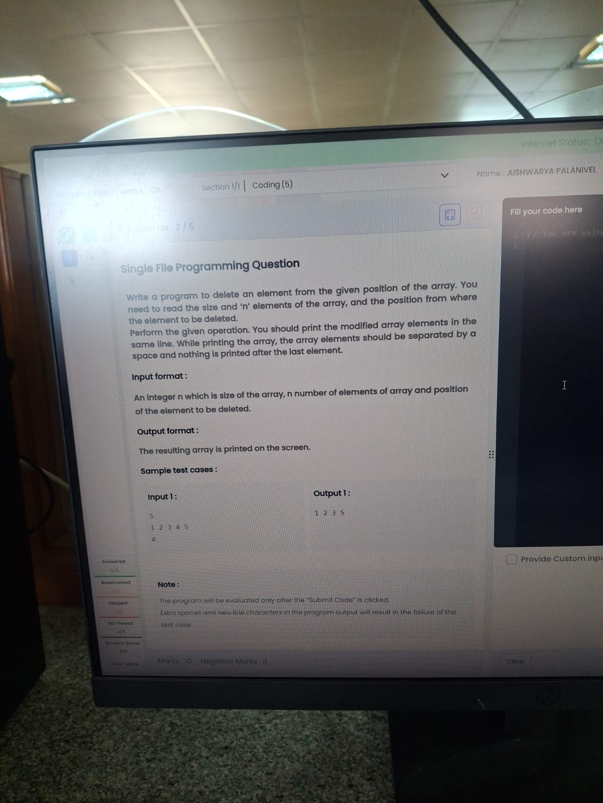
import java.util.Scanner;
public class Main {
public static void main(String[] args) {
Scanner sc = new Scanner(System.in);
int n = sc.nextInt();
int[] a = new int[n];
for(int i = 0; i < n; i++)
a[i] = sc.nextInt();
int pos = sc.nextInt(); // 1-based position
for(int i = 0; i < n; i++) {
if(i != pos - 1) {
System.out.print(a[i]);
if(i < n - 1 && !(i == n - 2 && pos == n))
System.out.print(" ");
}
}
}
}
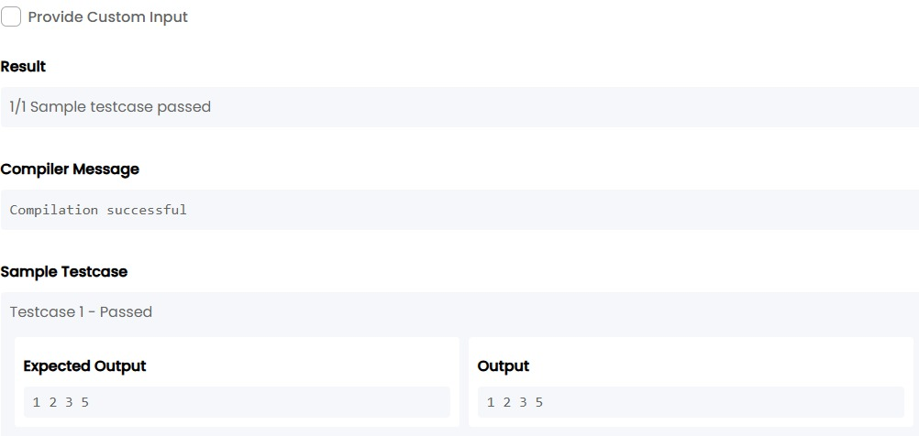
TASK9:
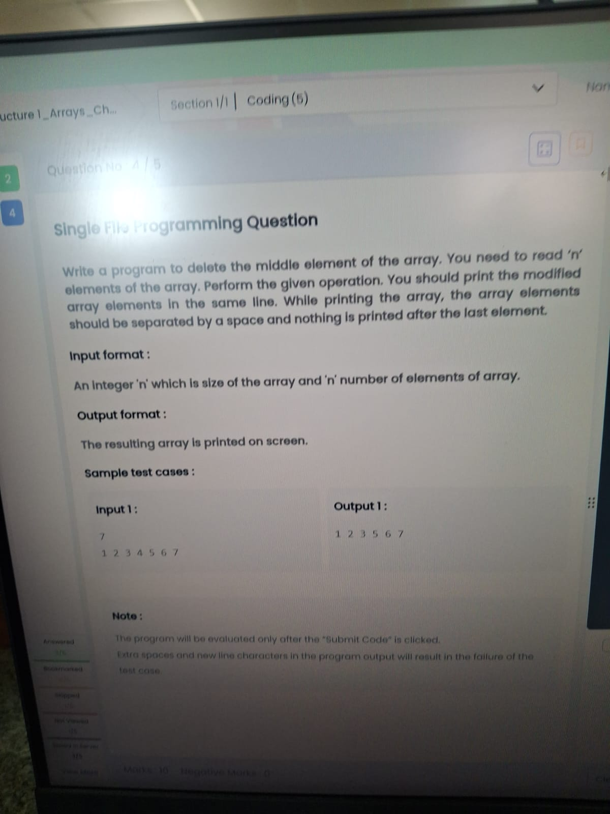
import java.util.Scanner;
public class Main {
public static void main(String[] args) {
Scanner sc = new Scanner(System.in);
int n = sc.nextInt();
int[] a = new int[n];
for(int i = 0; i < n; i++)
a[i] = sc.nextInt();
int mid = n / 2; // middle index
for(int i = 0; i < n; i++) {
if(i != mid) {
System.out.print(a[i]);
if(i != n - 1 && !(i == n - 2 && mid == n - 1))
System.out.print(" ");
}
}
}
}
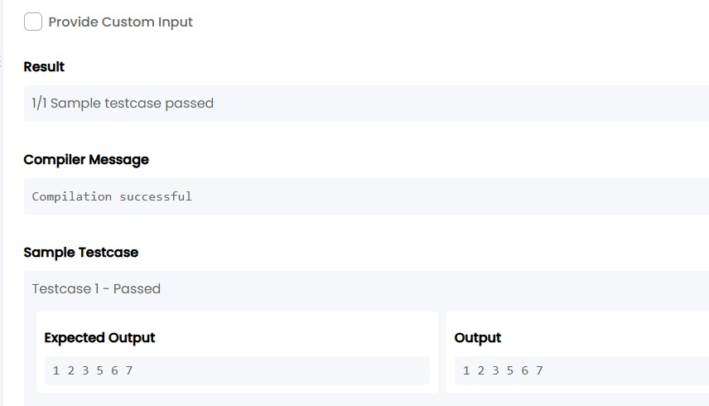

TASK10:
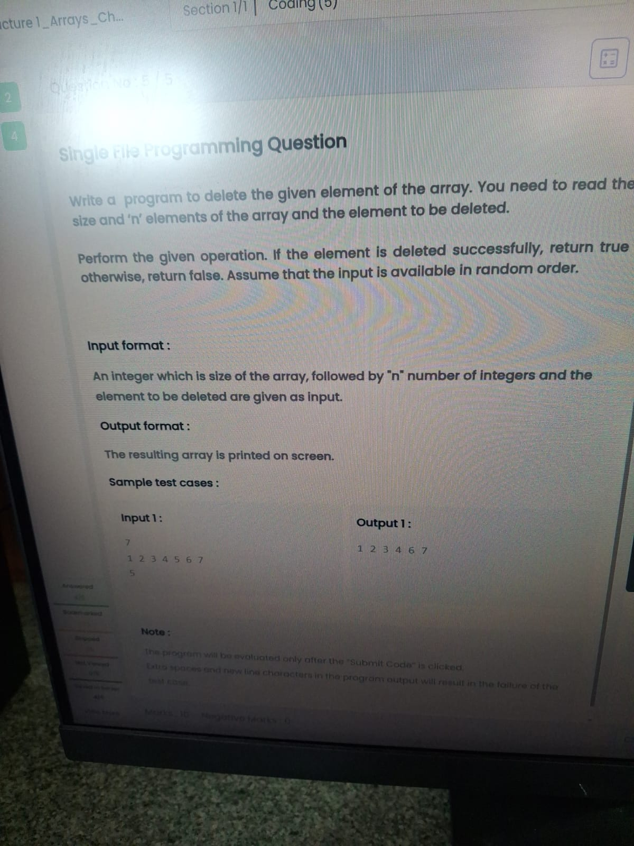
import java.util.Scanner;
public class Main {
public static void main(String[] args) {
Scanner sc = new Scanner(System.in);
int n = sc.nextInt();
int[] a = new int[n];
for(int i = 0; i < n; i++)
a[i] = sc.nextInt();
int del = sc.nextInt();
boolean found = false;
for(int i = 0; i < n; i++){
if(a[i] == del && !found){
found = true;
continue;
}
System.out.print(a[i]);
if(i < n - 1)
System.out.print(" ");
}
if(!found)
System.out.print("false");
}
}

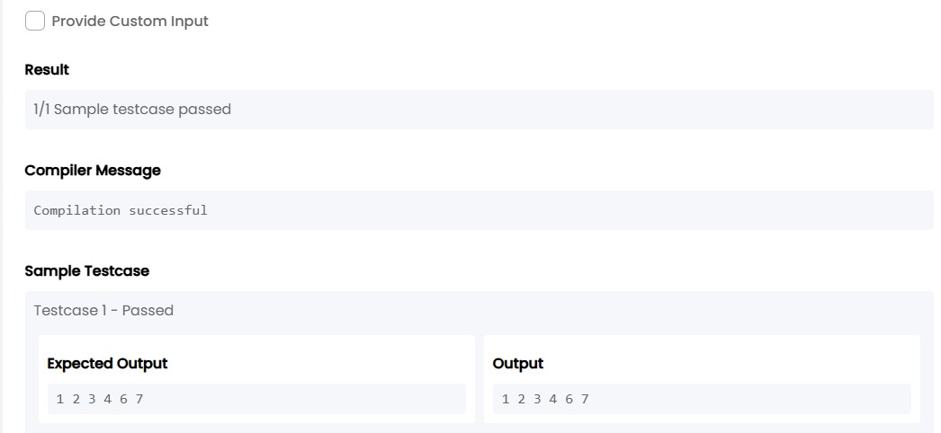

3. Data structure 4_Search & Sorting_Chapter1
TASK11:
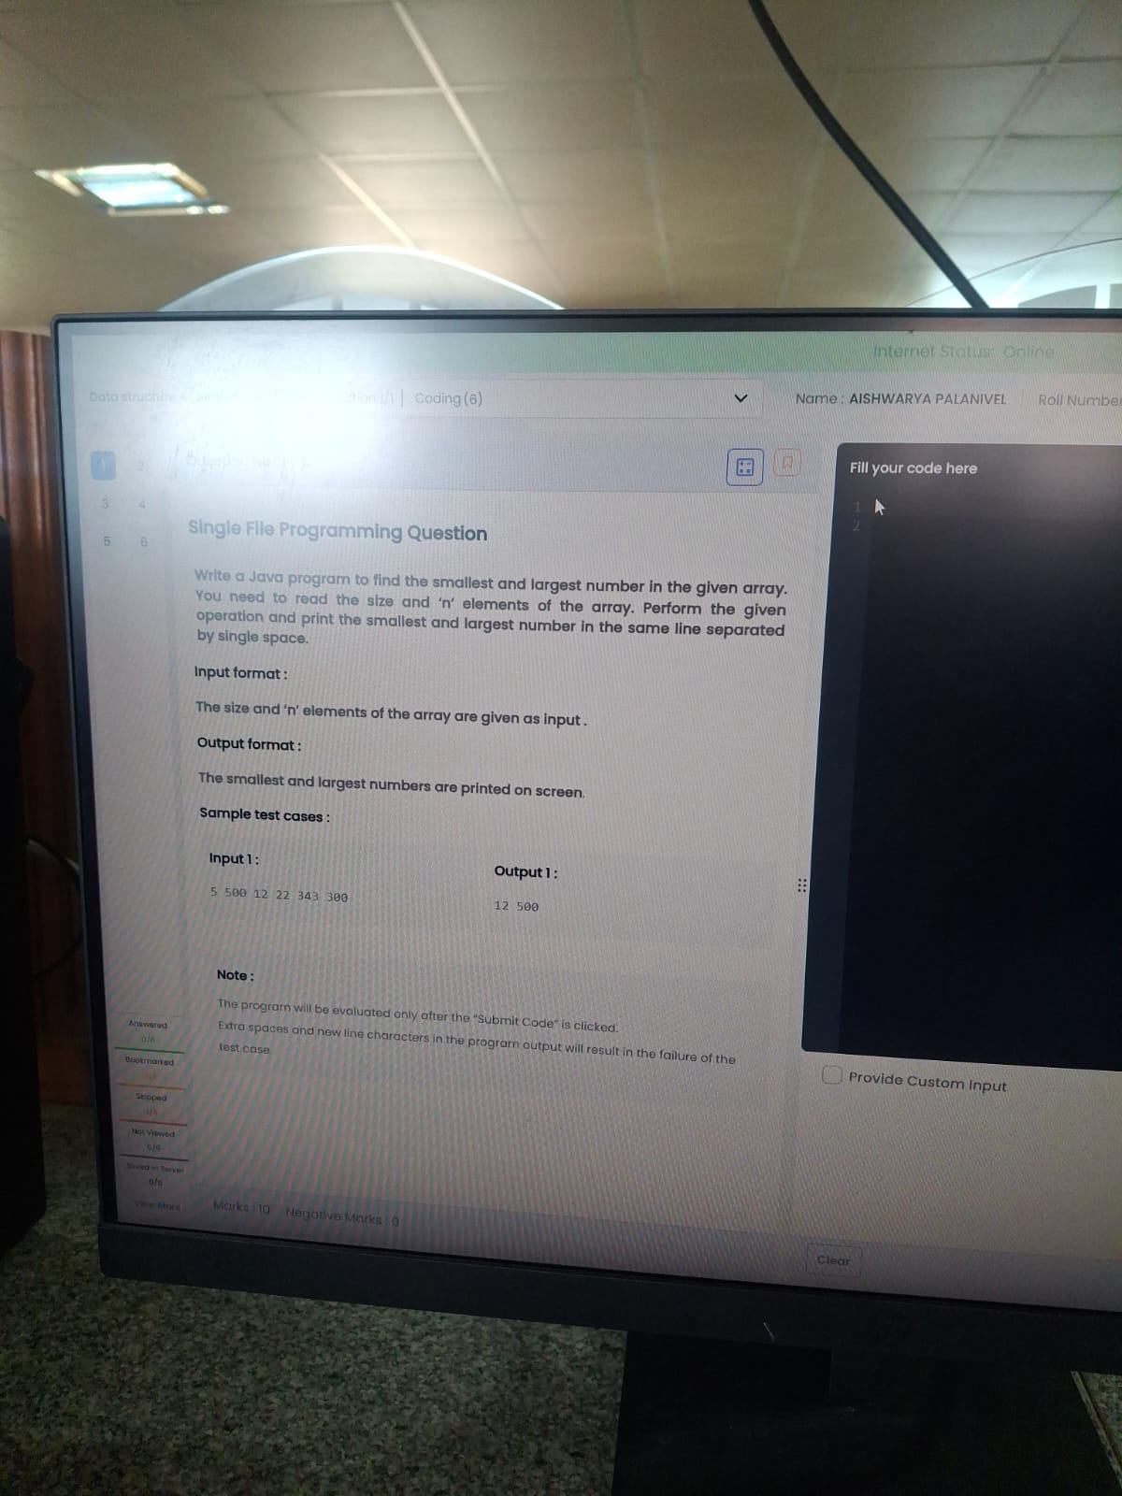
import java.util.Scanner;
public class Main {
public static void main(String[] args) {
Scanner sc = new Scanner(System.in);
int n = sc.nextInt();
int min = Integer.MAX_VALUE;
int max = Integer.MIN_VALUE;
for(int i = 0; i < n; i++){
int num = sc.nextInt();
if(num < min) min = num;
if(num > max) max = num;
}
System.out.print(min + " " + max);
}
}

TASK12:
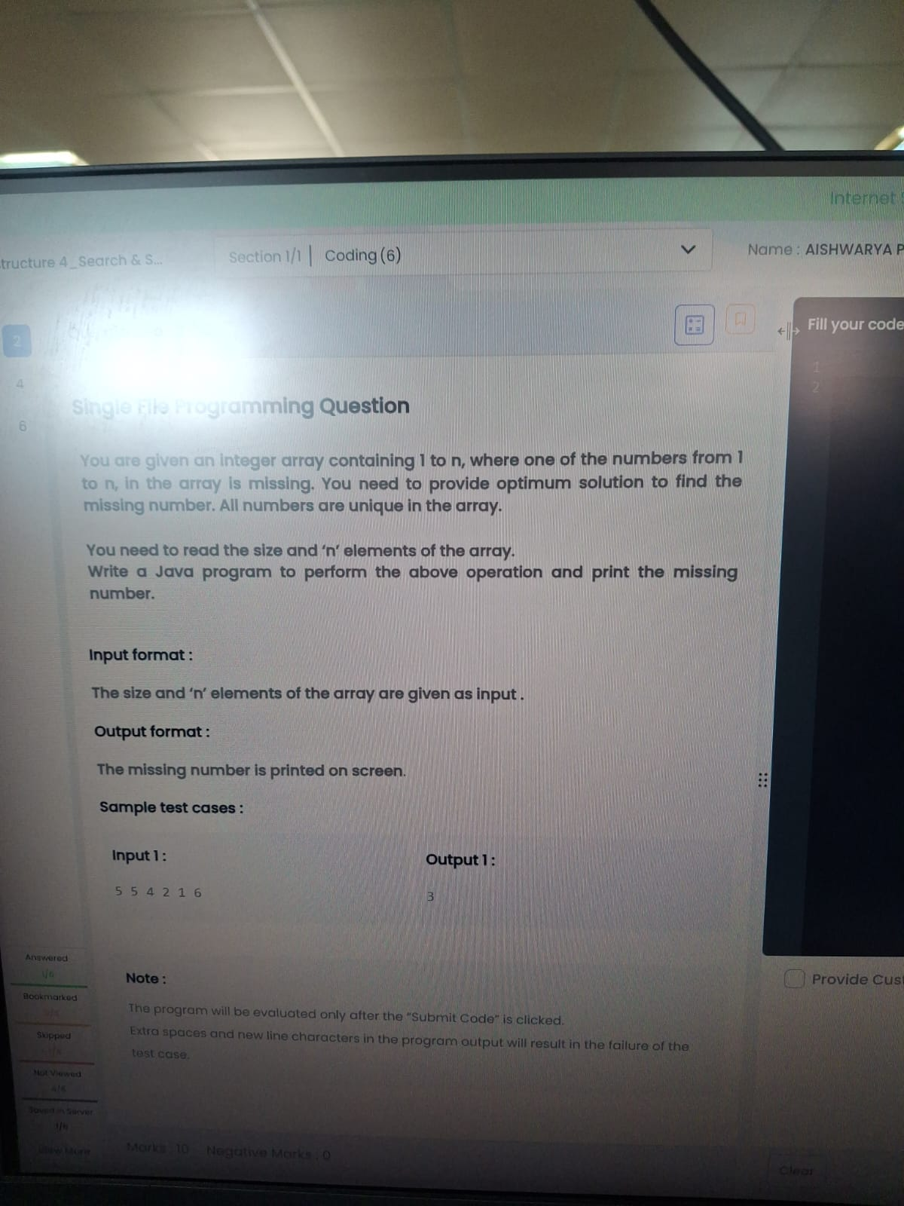
import java.util.Scanner;
import java.util.Arrays;
public class Main {
public static void main(String[] args) {
Scanner sc = new Scanner(System.in);
int n = sc.nextInt();
int[] a = new int[n];
for(int i = 0; i < n; i++)
a[i] = sc.nextInt();
Arrays.sort(a);
for(int i = 0; i < n - 1; i++) {
if(a[i+1] - a[i] != 1) {
System.out.print(a[i] + 1);
return;
}
}
}
}
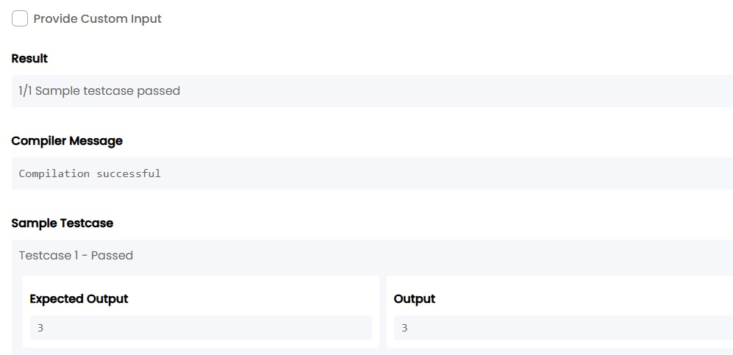
TASK13:
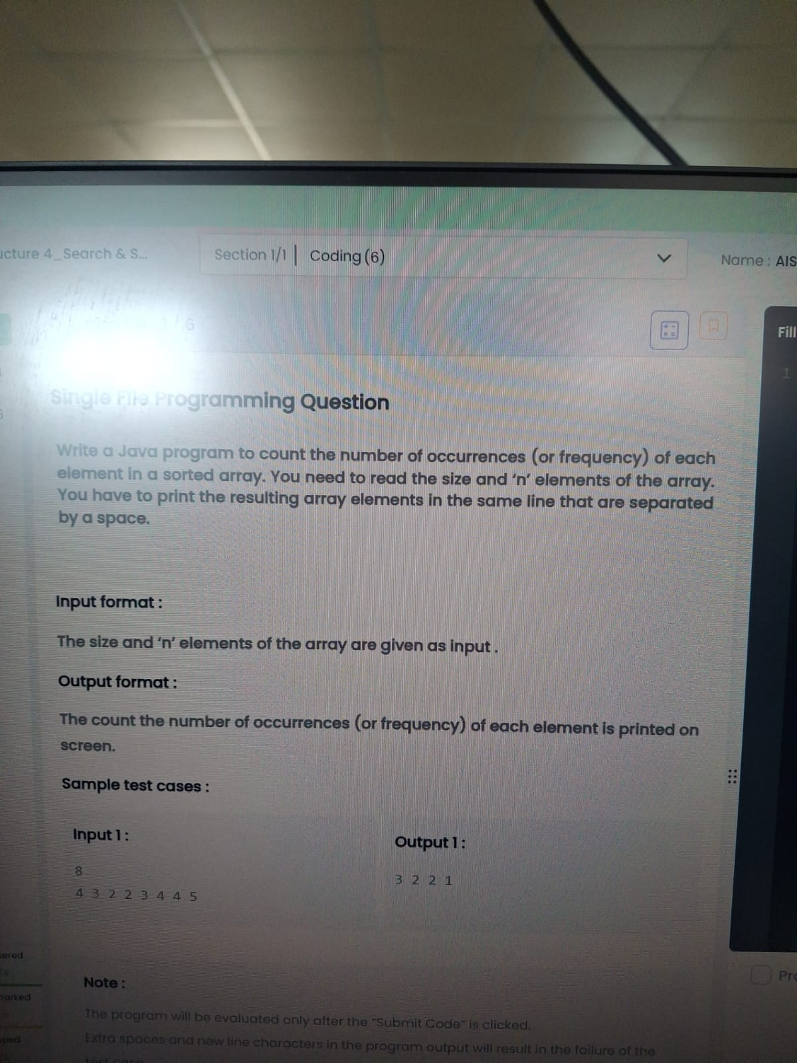
import java.util.*;
public class Main {
public static void main(String[] args) {
Scanner sc = new Scanner(System.in);
int n = sc.nextInt();
int[] a = new int[n];
for(int i = 0; i < n; i++)
a[i] = sc.nextInt();
LinkedHashMap<Integer,Integer> map = new LinkedHashMap<>();
for(int i = 0; i < n; i++)
map.put(a[i], map.getOrDefault(a[i],0)+1);
for(int val : map.values())
System.out.print(val + " ");
}
}

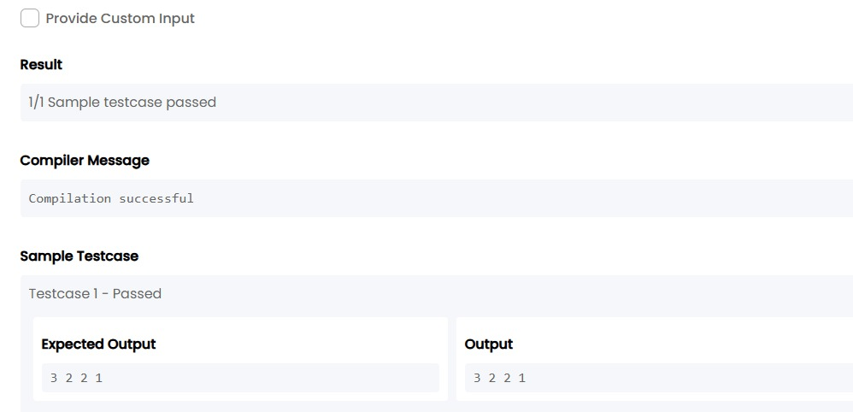
TASK14:

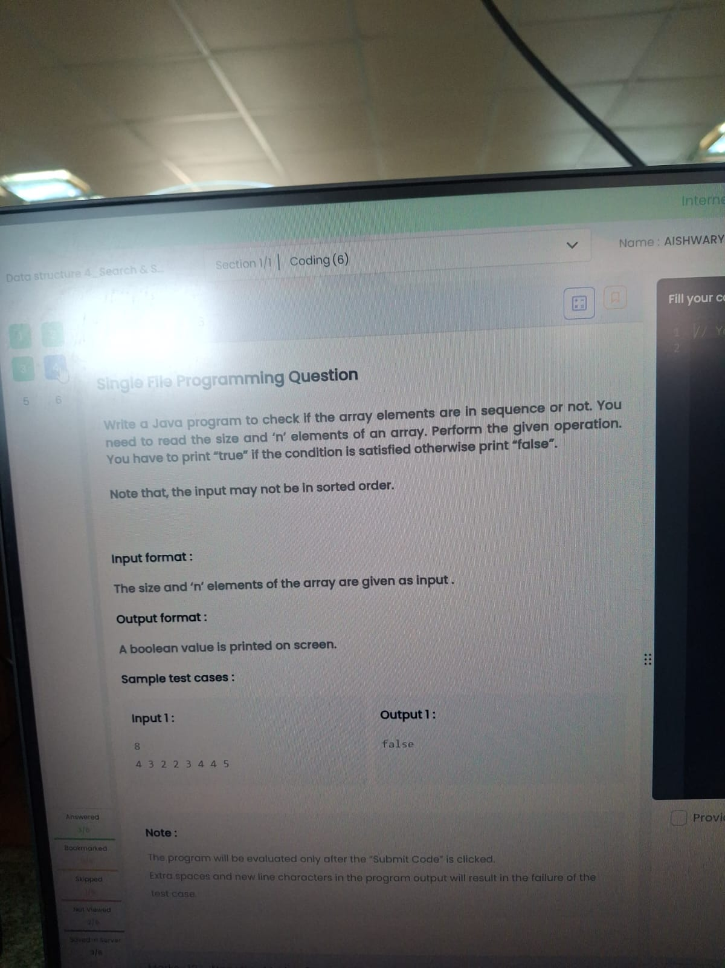
import java.util.*;
public class Main {
public static void main(String[] args) {
Scanner sc = new Scanner(System.in);
int n = sc.nextInt();
int[] a = new int[n];
for(int i = 0; i < n; i++)
a[i] = sc.nextInt();
Arrays.sort(a);
boolean flag = true;
for(int i = 1; i < n; i++) {
if(a[i] != a[i-1] + 1) {
flag = false;
break;
}
}
System.out.print(flag);
}
}
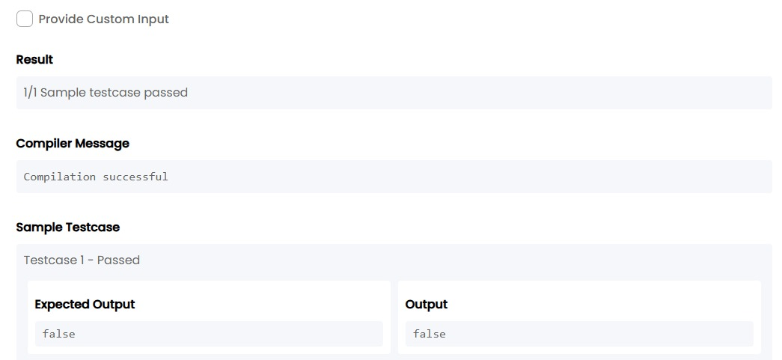

TASK15:

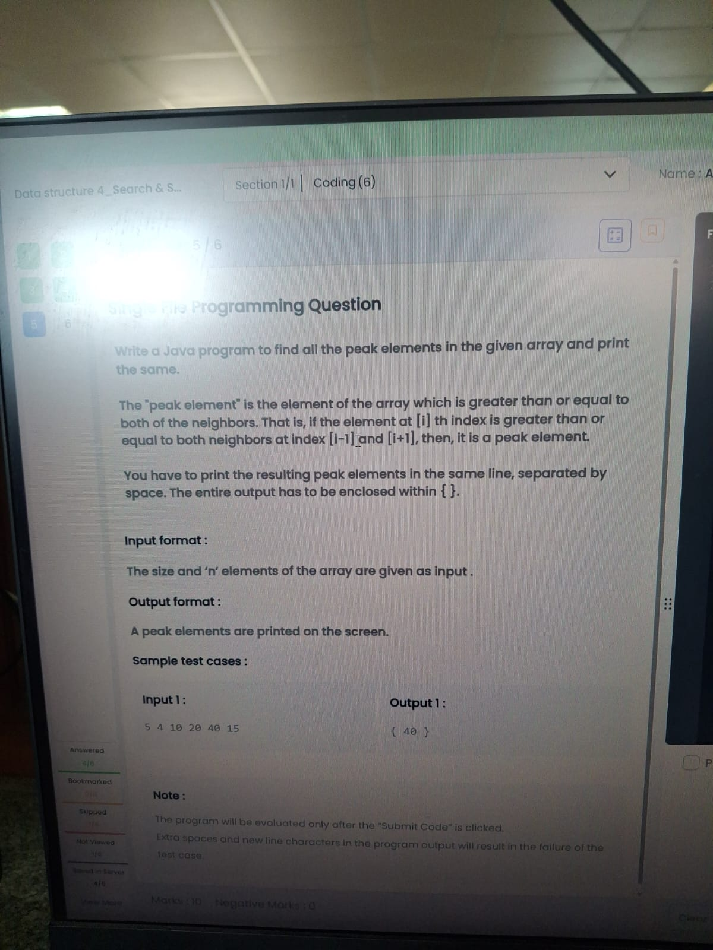
import java.util.*;
public class Main {
public static void main(String[] args) {
Scanner sc = new Scanner(System.in);
int n = sc.nextInt();
int[] a = new int[n];
for (int i = 0; i < n; i++)
a[i] = sc.nextInt();
System.out.print("{ ");
boolean first = true;
for (int i = 1; i < n - 1; i++) {
if (a[i] >= a[i - 1] && a[i] >= a[i + 1]) {
if (!first)
System.out.print(" ");
System.out.print(a[i]);
first = false;
}
}
System.out.print(" }");
}
}
TASK16:
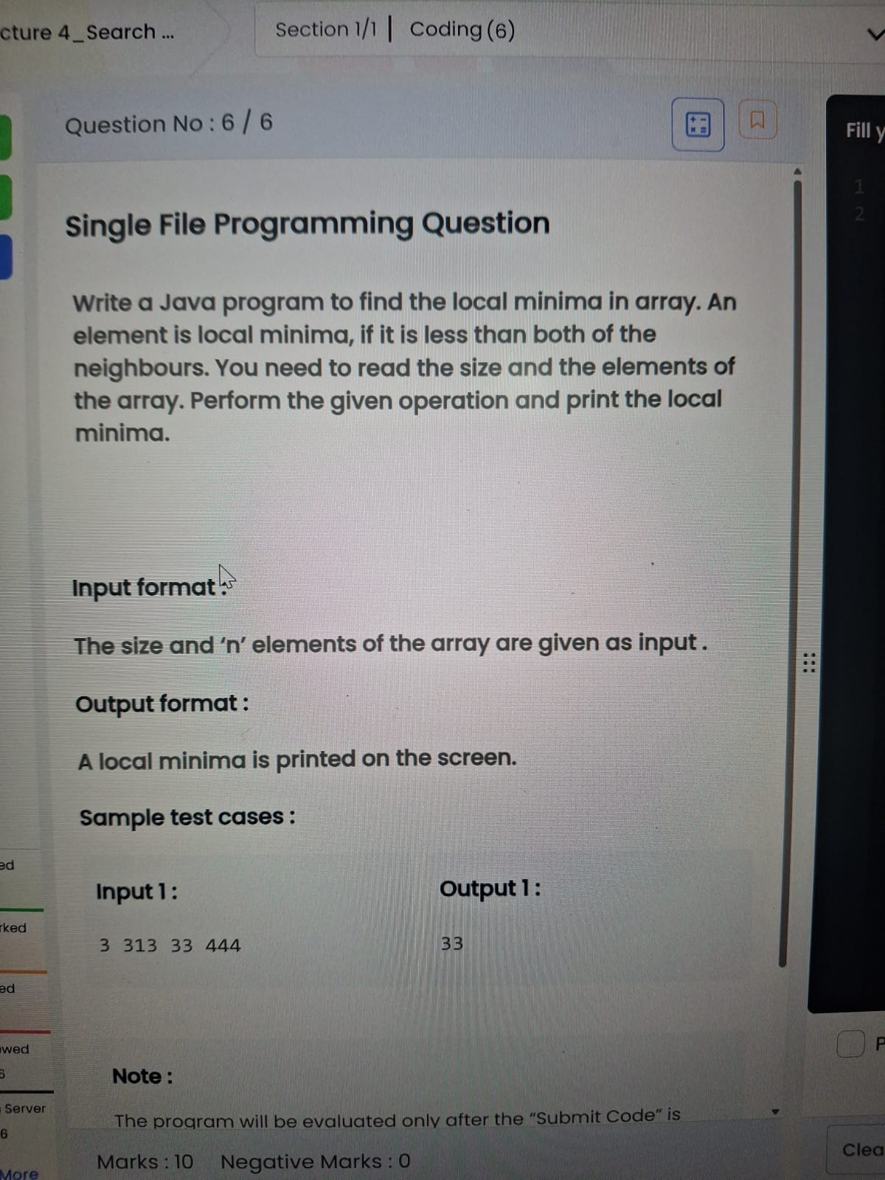
import java.util.*;
public class Main {
public static void main(String[] args) {
Scanner sc = new Scanner(System.in);
int n = sc.nextInt();
int[] a = new int[n];
for(int i=0;i<n;i++)
a[i]=sc.nextInt();
boolean first = true;
if(n==1){
System.out.print(a[0]);
return;
}
// First element
if(a[0] < a[1]){
System.out.print(a[0]);
first = false;
}
// Middle elements
for(int i=1;i<n-1;i++){
if(a[i] < a[i-1] && a[i] < a[i+1]){
if(!first) System.out.print(" ");
System.out.print(a[i]);
first = false;
}
}
// Last element
if(a[n-1] < a[n-2]){
if(!first) System.out.print(" ");
System.out.print(a[n-1]);}}}

4. Data structure 4_Search & Sorting_Chapter 2
TASK17:

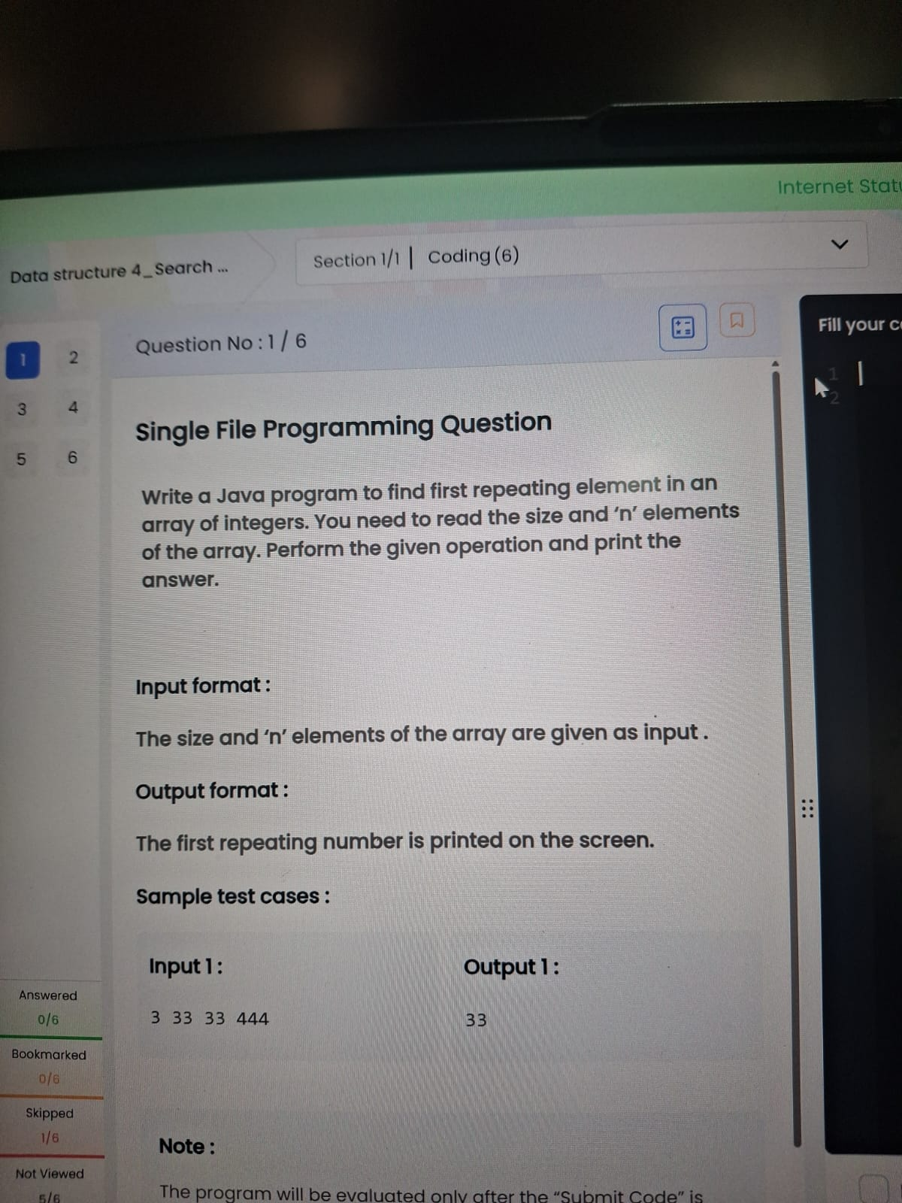
import java.util.*;
public class Main {
public static void main(String[] args) {
Scanner sc = new Scanner(System.in);
int n = sc.nextInt();
int[] a = new int[n];
for(int i=0;i<n;i++)
a[i]=sc.nextInt();
for(int i=0;i<n;i++){
for(int j=i+1;j<n;j++){
if(a[i]==a[j]){
System.out.print(a[i]);
return;
}
}
}
}
}
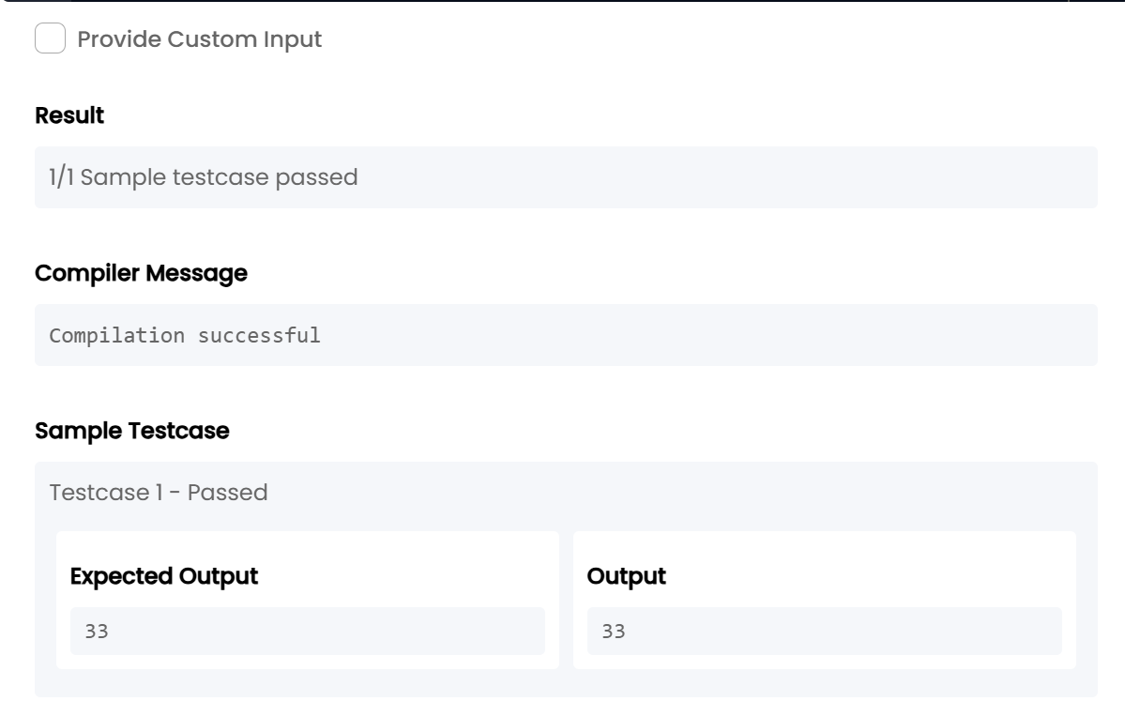
TASK18:

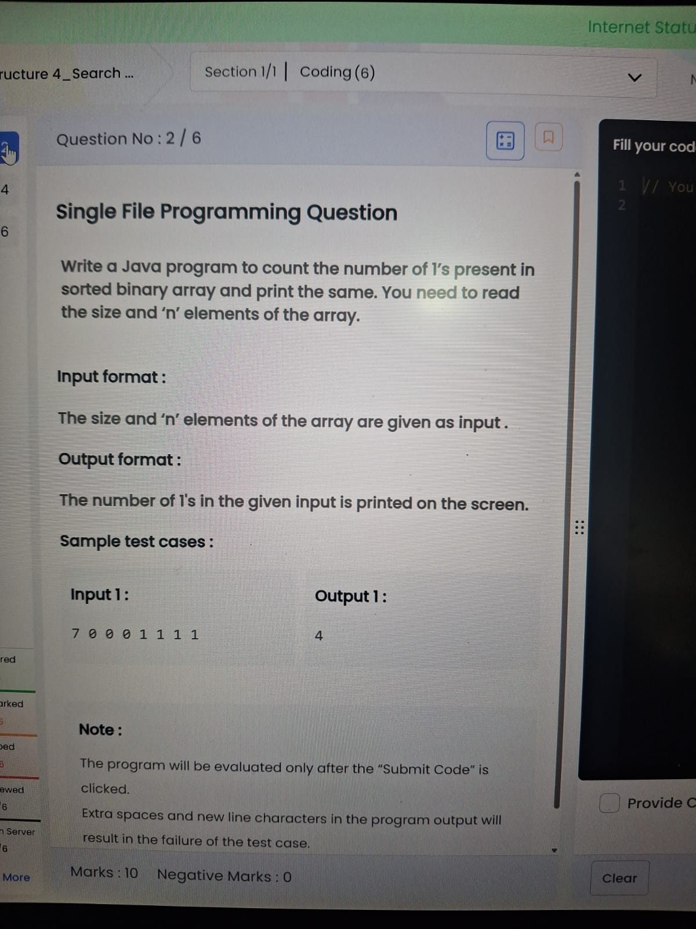
import java.util.*;
public class Main {
public static void main(String[] args) {
Scanner sc = new Scanner(System.in);
int n = sc.nextInt();
int count = 0;
for(int i = 0; i < n; i++)
if(sc.nextInt() == 1)
count++;
System.out.print(count);
}
}
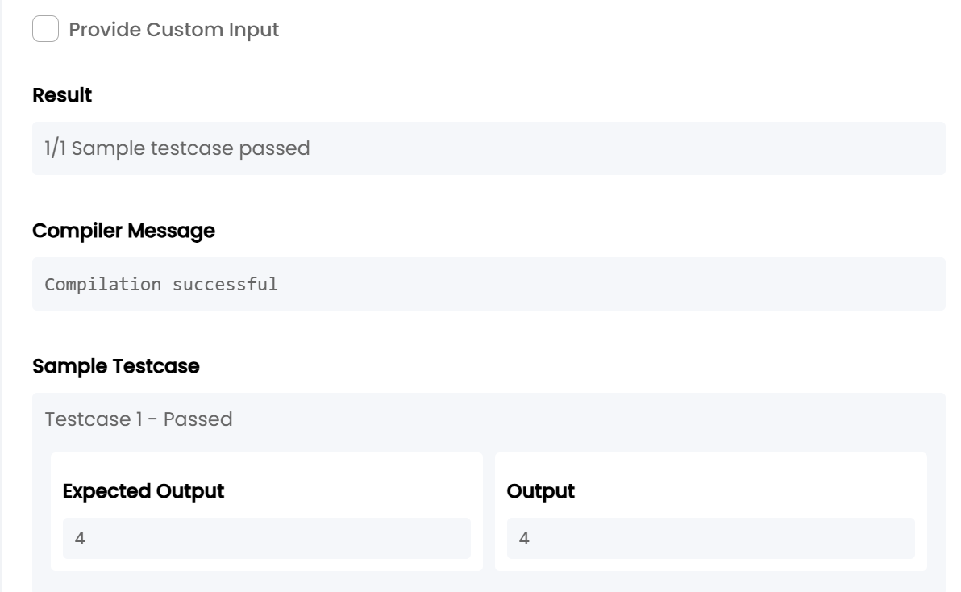

TASK19:

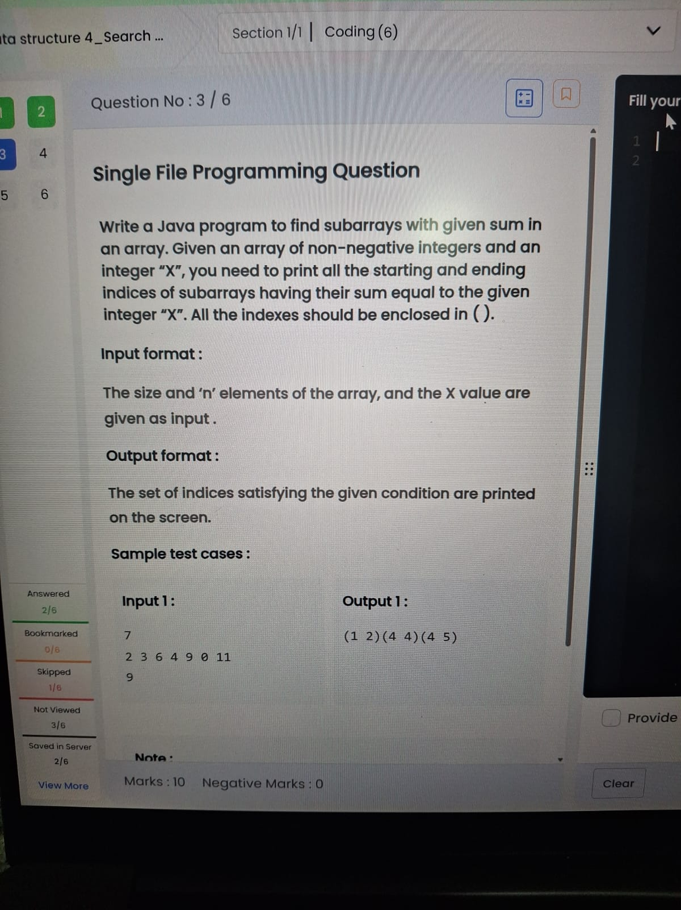
import java.util.*;
public class Main {
public static void main(String[] args) {
Scanner sc = new Scanner(System.in);
int n = sc.nextInt();
int[] a = new int[n];
for(int i=0;i<n;i++)
a[i]=sc.nextInt();
int x = sc.nextInt();
for(int i=0;i<n;i++){
int sum=0;
for(int j=i;j<n;j++){
sum+=a[j];
if(sum==x)
System.out.print("("+i+" "+j+")");
}
}
}
}
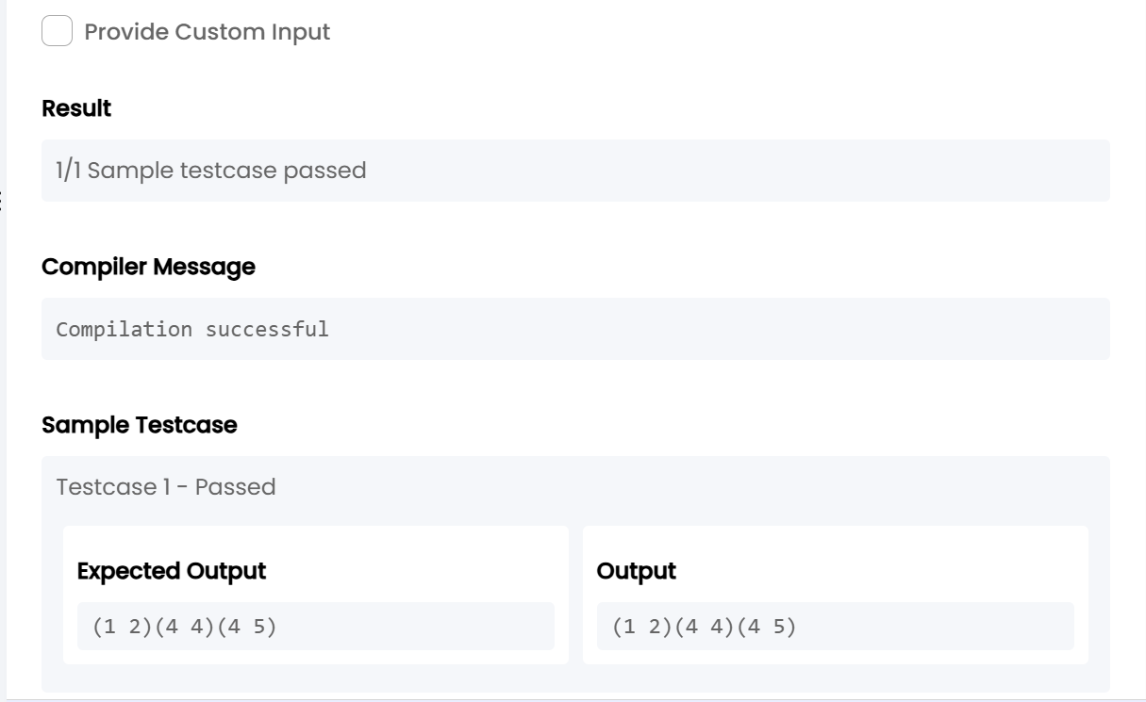
TASK20:

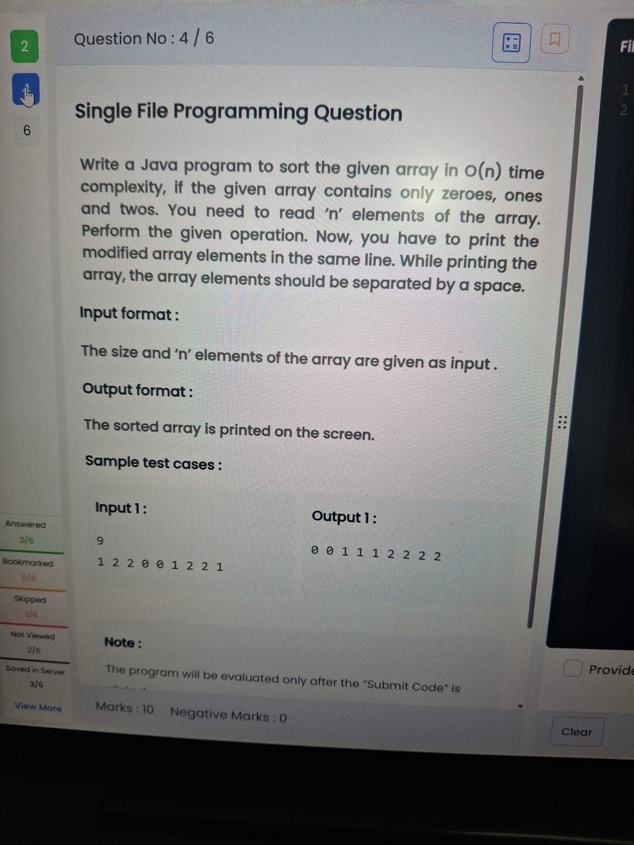
import java.util.*;
public class Main {
public static void main(String[] args) {
Scanner sc = new Scanner(System.in);
int n = sc.nextInt();
int[] a = new int[n];
for(int i=0;i<n;i++)
a[i] = sc.nextInt();
int c0=0,c1=0,c2=0;
for(int i=0;i<n;i++){
if(a[i]==0) c0++;
else if(a[i]==1) c1++;
else c2++;
}
for(int i=0;i<c0;i++) System.out.print("0 ");
for(int i=0;i<c1;i++) System.out.print("1 ");
for(int i=0;i<c2;i++) System.out.print("2 ");
}
}
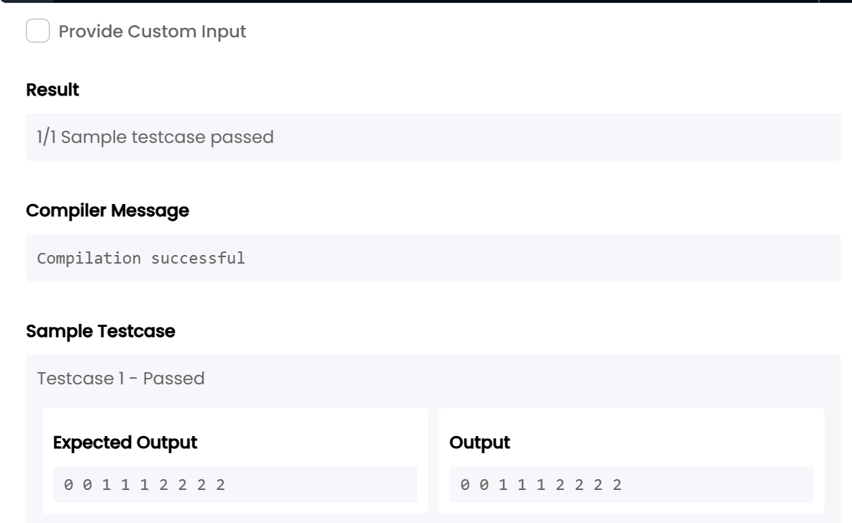
TASK21:

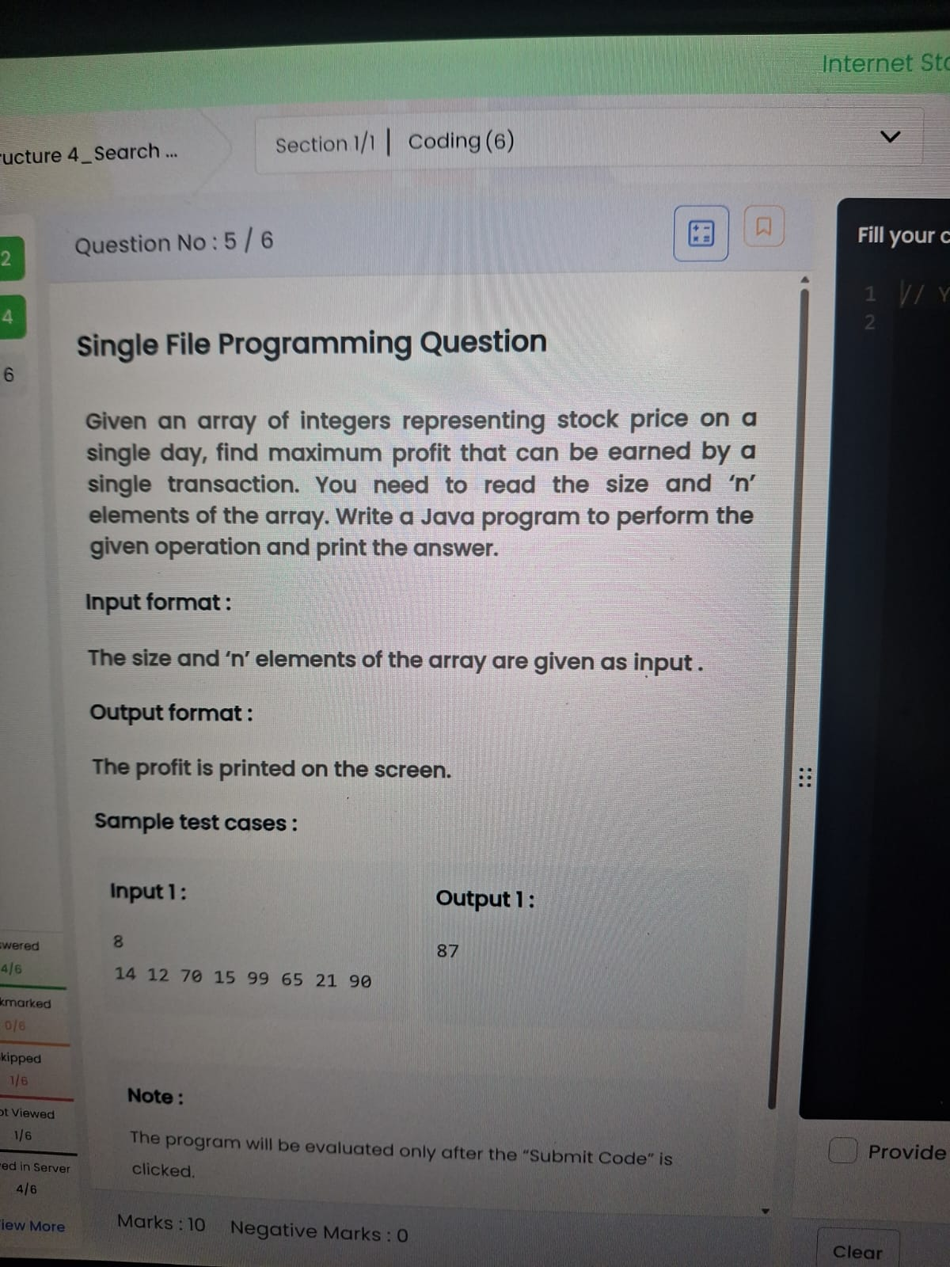
import java.util.*;
public class Main {
public static void main(String[] args) {
Scanner sc = new Scanner(System.in);
int n = sc.nextInt();
int min = Integer.MAX_VALUE, profit = 0;
for(int i = 0; i < n; i++) {
int price = sc.nextInt();
if(price < min)
min = price;
else if(price - min > profit)
profit = price - min;
}
System.out.print(profit);
}
}
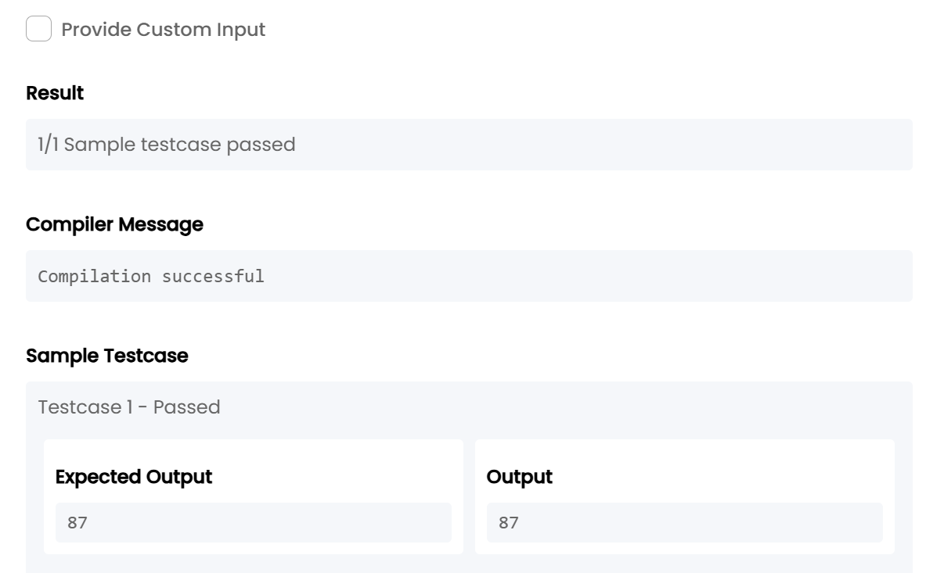
TASK22:

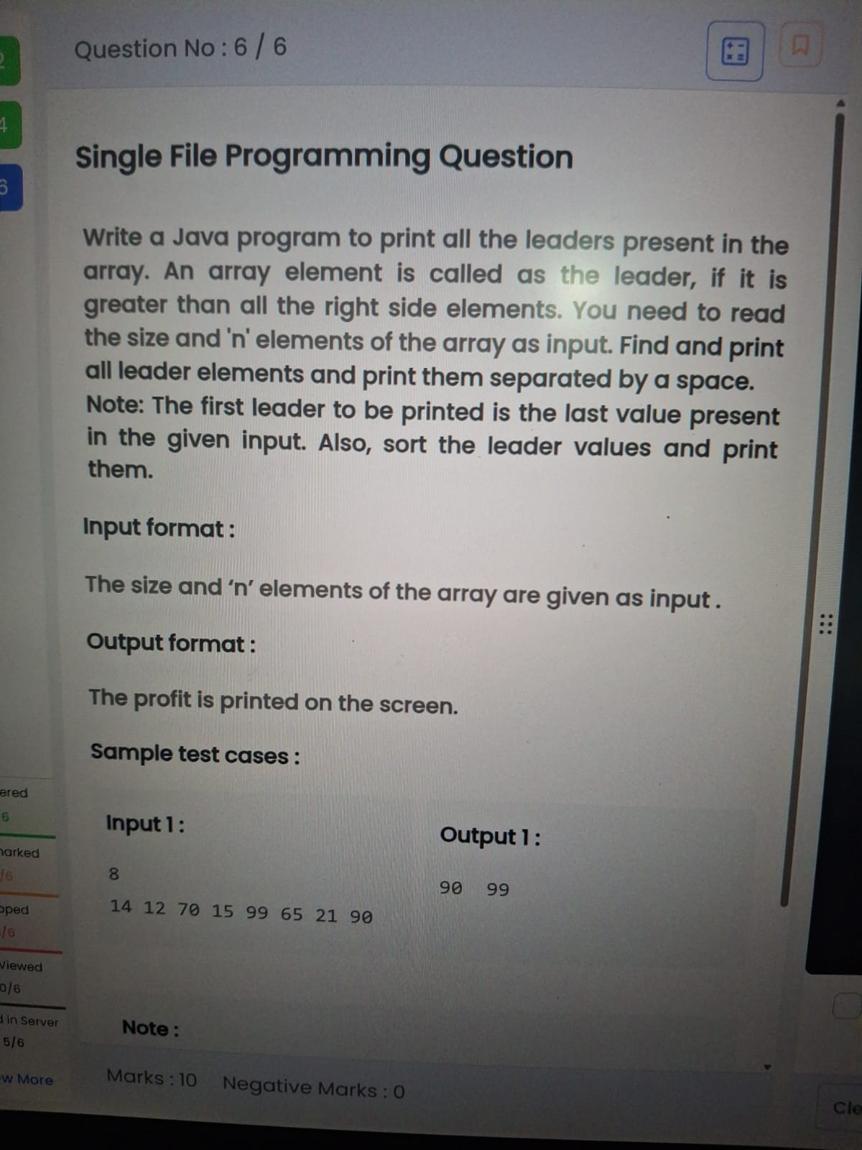
import java.util.*;
public class Main {
public static void main(String[] args) {
Scanner sc = new Scanner(System.in);
int n = sc.nextInt();
int[] a = new int[n];
for(int i=0;i<n;i++)
a[i] = sc.nextInt();
ArrayList<Integer> list = new ArrayList<>();
int max = Integer.MIN_VALUE;

for(int i=n-1;i>=0;i--){
if(a[i] > max){
list.add(a[i]);
max = a[i];
}
}
Collections.sort(list);
for(int i=0;i<list.size();i++)
System.out.print(list.get(i)+" ");
}
}
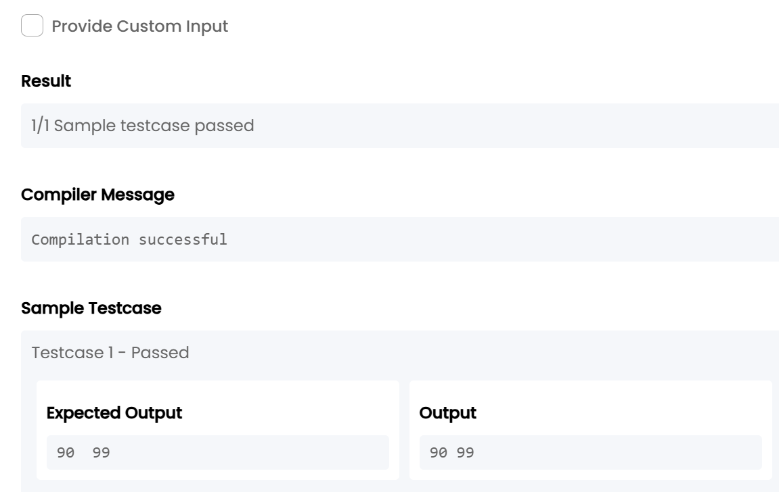
5. Data structure 4_Search & Sorting_Chapter 3
TASK23:

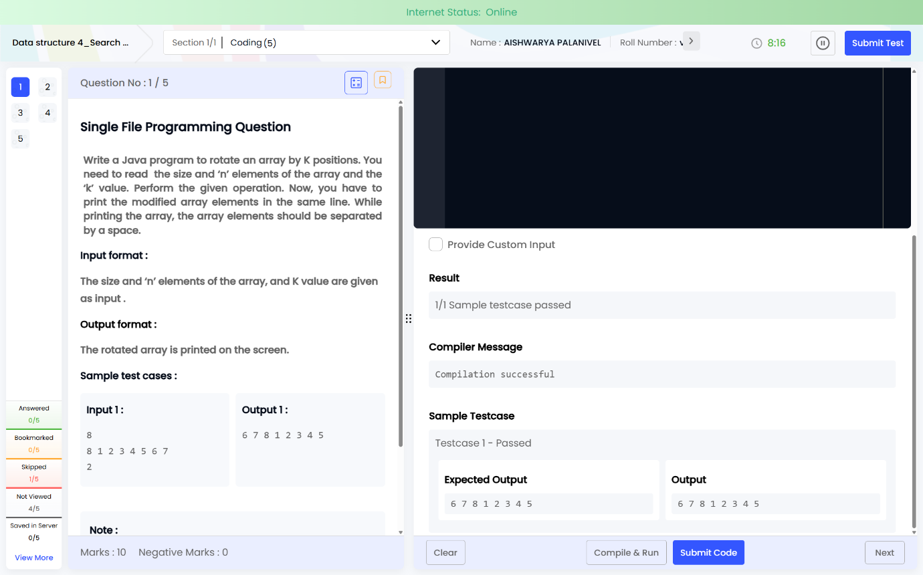
import java.util.*;
public class Main {
public static void main(String[] args) {
Scanner sc = new Scanner(System.in);
int n = sc.nextInt();
int[] a = new int[n];
for(int i=0;i<n;i++)
a[i] = sc.nextInt();
int k = sc.nextInt();
k = k % n;
for(int i=n-k;i<n;i++)
System.out.print(a[i]+" ");
for(int i=0;i<n-k;i++)
System.out.print(a[i]+" ");
}
}
TASK24:

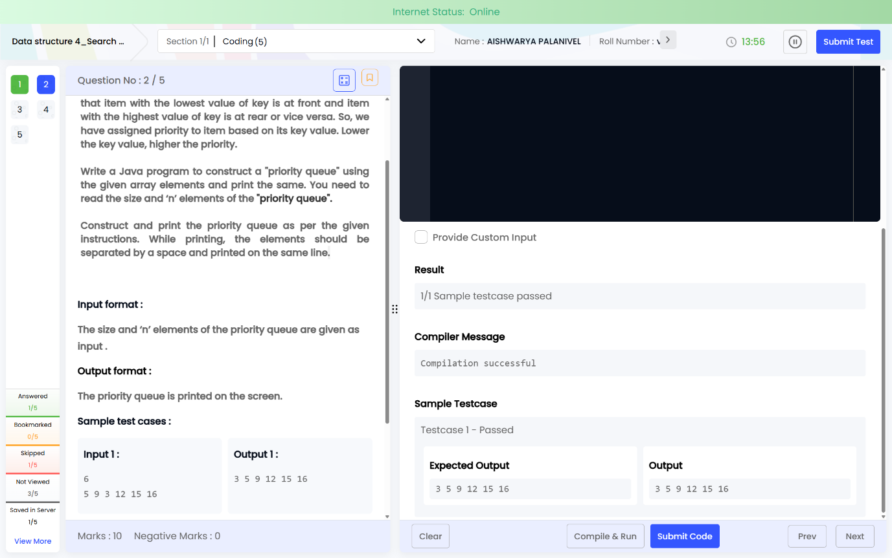
import java.util.*;
public class Main {
public static void main(String[] args) {
Scanner sc = new Scanner(System.in);
int n = sc.nextInt();
PriorityQueue<Integer> pq = new PriorityQueue<>();
for(int i=0;i<n;i++)
pq.add(sc.nextInt());
while(!pq.isEmpty())
System.out.print(pq.poll()+" ");
}
}
TASK25:

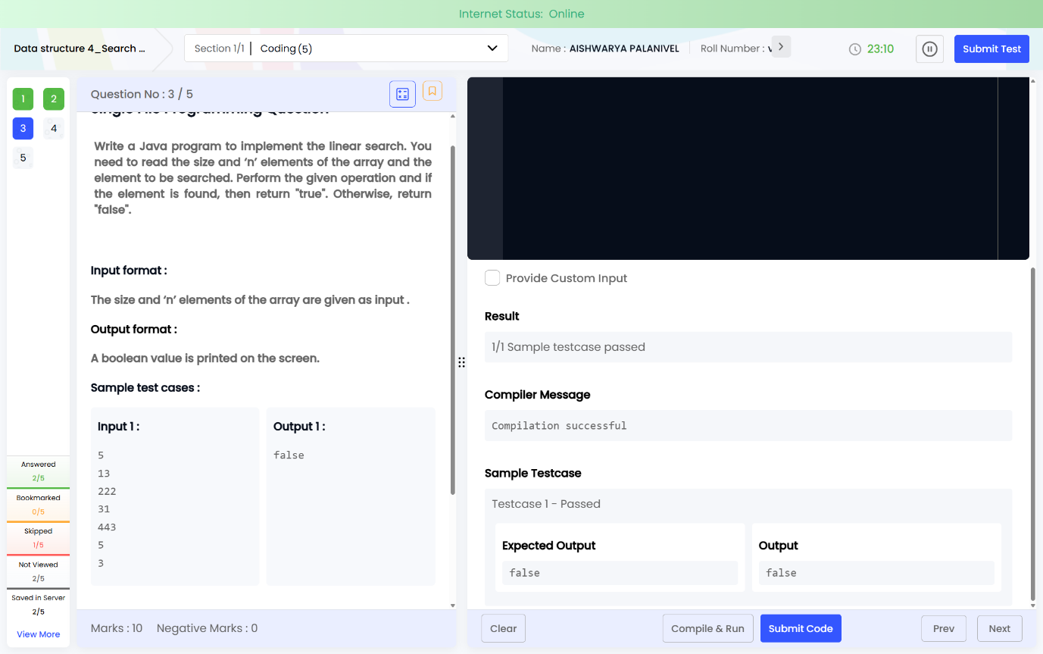
import java.util.*;
public class Main {
public static void main(String[] args) {
Scanner sc = new Scanner(System.in);
int n = sc.nextInt();
int[] a = new int[n];
for(int i=0;i<n;i++)
a[i] = sc.nextInt();
int key = sc.nextInt();
boolean found = false;
for(int i=0;i<n;i++)
if(a[i] == key)
found = true;
System.out.print(found);
}
}
TASK26:

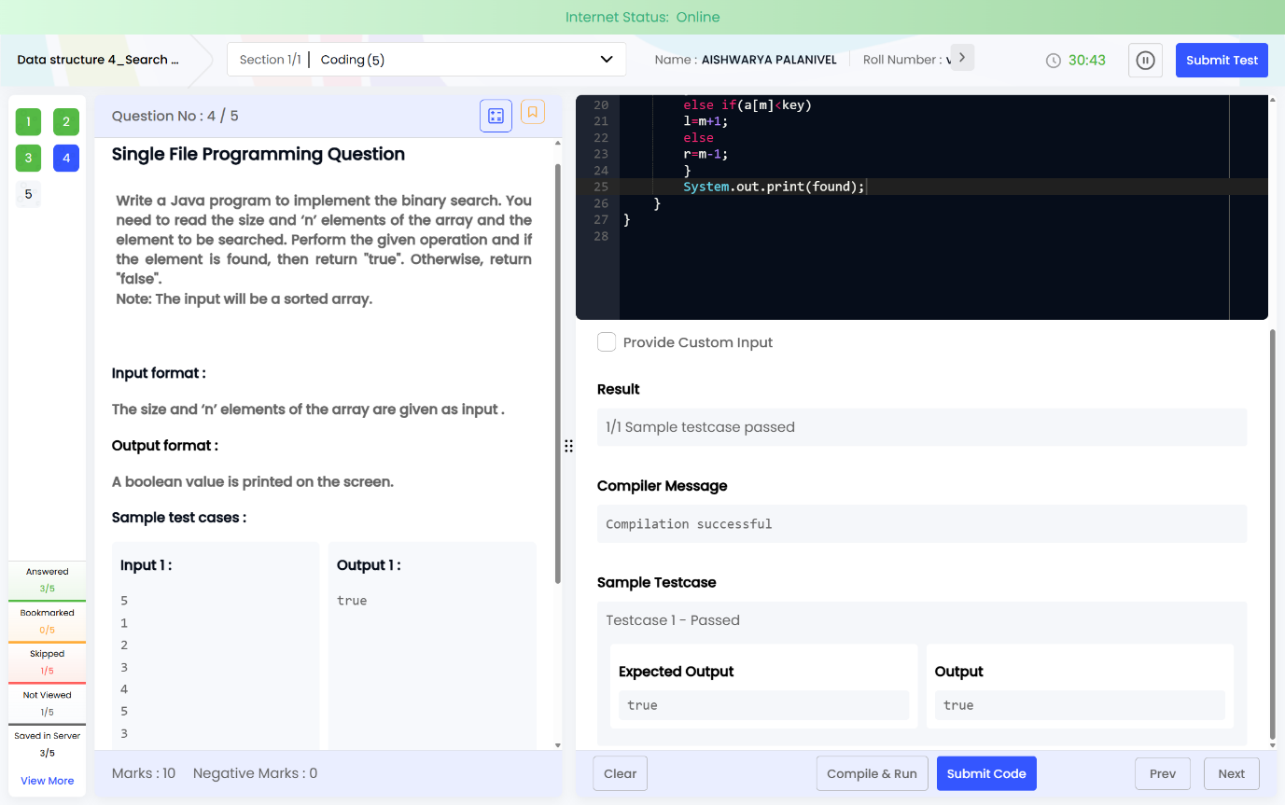
import java.util.*;
public class Main {
public static void main(String[] args) {
Scanner sc = new Scanner(System.in);
int n = sc.nextInt();
int[] a = new int[n];
for(int i=0;i<n;i++)
a[i] = sc.nextInt();
int key = sc.nextInt();
int l=0, r=n-1;
boolean found=false;
while(l<=r){
int m=(l+r)/2;
if(a[m]==key){
found=true;
break;
}
else if(a[m]<key)
l=m+1;
else
r=m-1;
}
System.out.print(found);
}
}
TASK27:
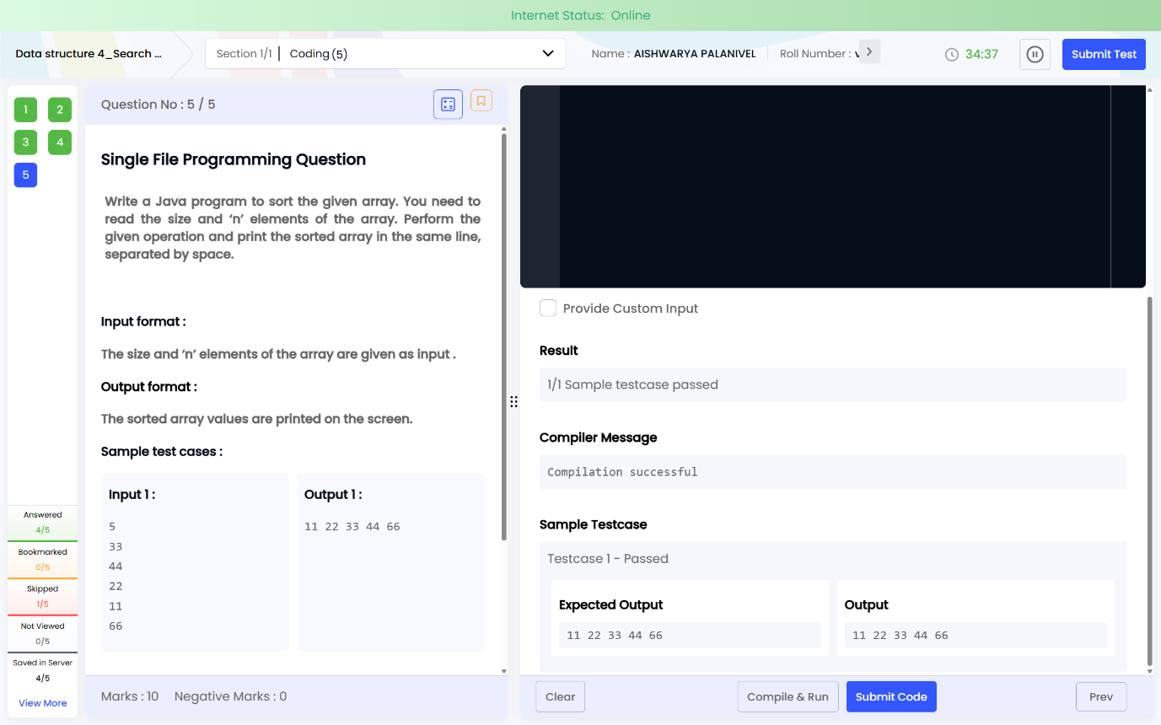
import java.util.*;
public class Main {
public static void main(String[] args) {
Scanner sc = new Scanner(System.in);
int n = sc.nextInt();
int[] a = new int[n];
for(int i=0;i<n;i++)
a[i] = sc.nextInt();
Arrays.sort(a);
for(int i=0;i<n;i++)
System.out.print(a[i] + " ");
}
}

